LU1. Introduce switched networks

Network switching is the process of channeling data received from any number of input ports to another designated port that will transmit the data to its desired destination

Switching is process to forward packets coming in from one port to a port leading towards the destination

What is Switched LAN architecture?

Switched LAN Architecture Hierarchical network design involves dividing the network into discrete layers. Each layer provides specific functions that define its role within the overall network.
LAN switching uses different kinds of network switches:
- Layer 2 switches
- Layer 3 switches
- Layer 4 switches
- Multi-layer switches
Layer 2 switches use the media access control address (MAC address) from the host's network interface cards (NICs) to decide where to forward frames.
Layer 3 switches are solely based on (destination) IP address stored in the header of IP datagram
The difference between a layer 3 switch and a router is the way the device is making the routing decision.
Traditionally, routers use microprocessors to make forwarding decisions in software, while the switch performs only hardware-based packet switching
Layer 4 switches means hardware-based layer 3 switching technology that can also consider the type of network traffic (for example, distinguish between HTTP, FTP or VoIP). Layer 4
switching provides additional datagram inspection by reading the port numbers found in the Transport layer header to make routing decisions (i.e. ports used by UDP or TCP).
Multi-layer switching combines layer 2, 3 and 4 switching technologies and provides high-speed
scalability with low latency. It accomplishes this high combination of high-speed scalability with
low latency by using huge filter tables based on the criteria designed by the network
administratormn

BENEFITS OF HIERARCHICAL NETWORK DESIGN
The main benefits of Cisco Three-Layer hierarchical model is that it helps to design, deploy and maintain a Scalable, trustworthy, cost effective hierarchical inter-network.
Better Performance: Cisco Three Layer Network Model allows in creating high performance networks
Better management & troubleshooting: Cisco Three Layer Network Model allows better network management and isolate causes of network troubles.
Better Filter/Policy creation and application: Cisco Three Layer Network Model allows better filter/policy creation application.
Better Scalability: Cisco Three Layer Network Model allows us to efficiently accommodate future growth.
Better Redundancy: Cisco Three Layer Network Model provides better redundancy. Multiple links across multiple devices provides better redundancy. If one switch is down, we have another alternate path to reach the destination
- Principal of hierarchical network design

What is hierarchical network design

A hierarchical network design involves dividing the network into discrete layers. Each layer, or tier, in the hierarchy provides specific functions that define its role within the overall network.
Principles of Hierarchical Network Design
✓ Convergence
✓ Separating video, voice and Data network
✓ Introduction to converged network
1. When designing a hierarchical network topology, consider the network diameter, which is the number of devices that a packet has to cross before it reaches its destination. Keeping the network diameter low ensures low and predictable latency between devices.

2. Each layer in the hierarchical network model is a possible candidate for bandwidth aggregation, which allows multiple switch port links to be combined so as to achieve higher throughput between switches.

3. Redundancy can be provided in a number of ways, including by doubling up the network connections between devices or doubling the devices themselves. Design requirements, such as the level of performance or redundancy necessary, are determined by the business goals of the organization
.
4.Convergence What Is a Converged Network? Convergence is the process of combining both voice and video communications on a data network. Converged networks have existed for a while now, but were only feasible in large enterprise organizations because of the high network costs.

Converged networks also required extensive management in relation to Quality of Service (QoS), because voice and video data traffic needed to be classified and prioritized on the network. Few individuals had the expertise in voice, video, and data networks to make convergence feasible and functional. In addition, heritage equipment hinders the process of moving toward a converged network.
What are two benefits to implementing a converged network as opposed to implementing three separate networks?
1. Network to manage Lower costs:
Converged networks give you options that had not existed previously. There is no need for expensive handset phone or videoconferencing equipment.

2. You can accomplish the same function using special software integrated with a personal computer.

Software integrated on a PC eliminates an expensive handset.
The use of multiple communication modes on a single network offers convenience and flexibility that are not possible with separate infrastructures. Today, consumers, businesses, educational institutions and government agencies use an
expanded collection of media types, including:
Texting - the act of sending short, alphanumeric communications between cell phones, pagers or
other hand-held devices, as implemented by a wireless carrier.
Web surfing - exploring a sequence of web sites in a random, unplanned way, or simply using
the web to look for something in a questing way.
Voice over IP (VoIP) - the transmission of voice and multimedia content over Internet Protocol (IP) networks.
Streaming media - video or audio content sent in compressed form over the Internet and played
immediately, rather than being saved to the hard drive.
Videoconference applications - a live, visual connection between two or more people residing
in separate locations for the purpose of communication, Etc

Learning Outcome 1.2: Match Switches to specific LAN functions

CORE LAYER
Core Layer consists of biggest, fastest, and most expensive routers with the highest model numbers and Core Layer is considered as the back bone of networks. Core Layer routers are used to merge geographically separated networks. The Core Layer routers move information on the network as fast as possible. The switches operating at core layer switches packets as fast as possible.

DISTRIBUTION LAYER
The Distribution Layer is located between the access and core layers. The purpose of this layer is to provide boundary definition by implementing access lists and other filters. Therefore the Distribution Layer defines policy for the network. Distribution Layer includes high-end layer 3 switches. Distribution Layer ensures that packets are properly routed between subnets and VLANs in your enterprise.

ACCESS LAYER
Access layer includes access switches which are connected to the end devices (Computers, Printers, and Servers etc). Access layer switches ensures that packets are delivered to the end devices Quality of Service (QoS)
The benefit of dividing a flat network into smaller, more manageable blocks is that restricted traffic remains limited. Only traffic that is destined for other networks is moved to a higher layer.
Layer 2 devices in a flat network provide little opportunity to control broadcasts or to filter undesirable traffic. As more devices and applications are added to a flat network, response times degrade until the network becomes unusable.
Learning Outcome 1.2: Match Switches to specific LAN functions
•Consideration for hierarchical network switches
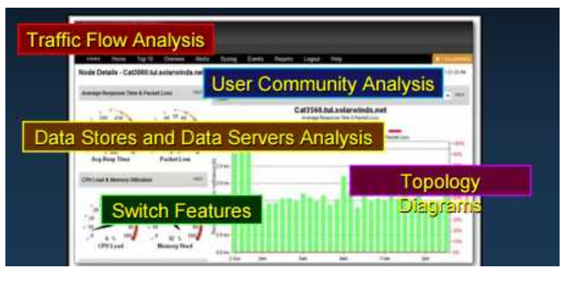
- Traffic flow analysis

Traffic Flow Analysis Traffic flow analysis is the process of measuring the bandwidth usage on a network and analyzing the data for the purpose of performance tuning(change)capacity planning, and making hardware improvement decisions

Analysis Tools Many traffic flow analysis tools that automatically record traffic flow data to a
database and perform a trend analysis are available. In large networks, software collection
solutions are the only effective method for performing traffic flow analysis.

- User communities analysis
User Communities Analysis :User community analysis is the process of identifying various groupings of users and their impact on network performance. The way users are grouped affects issues related to port density and traffic flow, which, in turn, influence the selection of network switches. In a typical office building, end users are grouped according to their job function, because they require similar access to resources and applications
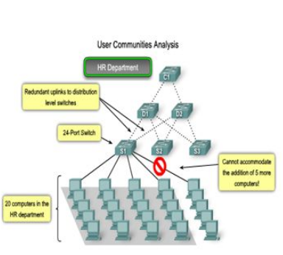

If you were to select an appropriate access layer switch to accommodate the HR department, you would probably choose a 24 port switch, which has enough ports to accommodate the 20 workstations and the uplinks to the distribution layer switches.

- Data stores and Data servers Analysis : When analyzing traffic on a network, consider where the data stores and servers are located so that you can determine the impact of traffic on the network. Data stores can be servers, storage area networks (SANs), network-attached storage (NAS), tape backup units, or any other device or component where large quantities of data are stored. When considering the traffic for data stores and servers, consider both client-server traffic and server-server traffic. Client-server traffic is the traffic generated when a client device accesses data from data stores or servers. Client-server traffic typically traverses multiple switches to reach its destination. Bandwidth aggregation and switch forwarding rates are important factors to consider when attempting to eliminate bottlenecks for this type of traffic. Server-server traffic is the traffic generated between data storage devices on the network. Some server applications generate very high volumes of traffic between data stores and other servers. To optimize server-server traffic, servers needing frequent access to certain resources should be located in close proximity to each other so that the traffic they generate does not affect the performance of the rest of the network

- Topology Diagrams A topology diagram is a graphical representation of a network infrastructure.A topology diagram shows how all switches are interconnected, detailed down to which switch port interconnects the devices.A topology diagram graphically displays any redundant paths or aggregated ports between switches that provide for resiliency and performance.It shows where and how many switches are in use on your network, as well as identifies their configuration.Topology diagrams can also contain information about device densities and user communities.Having a topology diagram allows you to visually identify potential bottlenecks in network traffic so that you can focus your traffic analysis data collection on areas where improvements can have the most significant impact on performance.A network topology can be very difficult to piece together after the fact if you were not part of the design process. Network cables in the wiring closets disappear into the floors and ceilings, making it difficult to trace their destinations.And because devices are spread throughout the building, it is difficult to know how all of the pieces are connected together.With patience, you can determine just how everything is interconnected and then document the network infrastructure in a topology diagram.
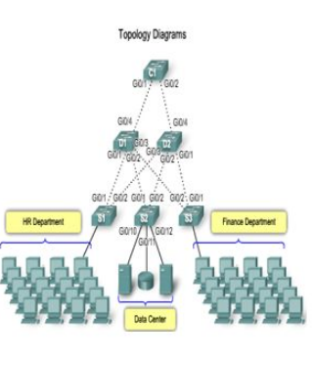
- Switch Features
- Switch Form Factors
When you are selecting a switch, you need to decide between
- Fixed configuration
- Modular configuration
- Stackable
- Fixed configuration
Fixed configuration switches means is that you cannot add features or options to the switch beyond those that originally came with the switch. For example, if you purchase a 24-port gigabit fixed switch, you cannot add additional ports when you need them
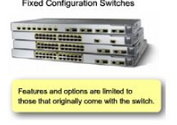
- Modular configuration
Modular switches typically come with different sized chassis that allow for the installation of different numbers of modular line cards. The line cards actually contain the ports.
The line card fits into the switch chassis like expansion cards fit into a PC. The larger the chassis, the more modules it can support. As you can see in the figure, there can be many different chassis sizes to choose from. If you bought a modular switch with a 24-port line card, you could easily add an additional 24 port line card, to bring the total number of ports up to 48.
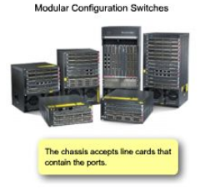

- Stackable
Stackable switches can be interconnected using a special backplane cable that provides high-bandwidth throughput between the switches. Cisco introduced StackWise technology in one of its switch product lines. As you can see in the figure, switches are stacked one atop of the other, and cables connect the switches in daisy chain fashion. The stacked switches effectively operate as a single larger switch. Stackable switches are desirable where fault tolerance and bandwidth availability are critical and a modular switch is too costly to implement. Using cross-connected connections, the network can recover quickly if a single switch fails. Stackable switches use a special port for interconnections and do not use line ports for inter-switch connections. The speeds are also typically faster than using line ports for connection switches
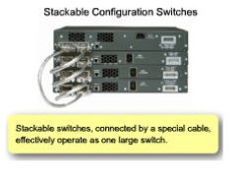

- Port density
When selecting a switch for the access, distribution, or core layers, consider the ability of the switch to support
- The port density,
- Forwarding rates
- Bandwidth aggregation
- Port Density.
- Port Density Port density is the number of ports available on a single switch.Fixed configuration switches typically support up to 48 ports on a single switch.If you have two switches that each contain 24 ports, you would be able to support up to 46 devices, because you lose at least one port per switch to connect each switch to the rest of the network. In addition, two power outlets are required. On the other hand

- Forwarding rates define the processing capabilities of a switch by rating how much data the switch can process per second. If the switch forwarding rate is too low, it cannot accommodate full wire-speed communication across all of its switch ports. For example, a 48-port gigabit switch operating at full wire speed generates 48 Gb/s of traffic. If the switch only supports a forwarding rate of 32 Gb/s, it cannot run at full wire speed across all ports simultaneously. Fortunately, access layer switches typically do not need to operate at full wire speed because they are physically limited by their uplinks to the distribution layer. This allows you to use less expensive, lower performing switches at the access layer, and use the more expensive, higher performing switches at the distribution and core layers, where the forwarding rate makes a bigger difference.

- As part of bandwidth aggregation, you should determine if there are enough ports on a switch to combine to support the required bandwidth. For example, consider a Gigabit Ethernet port, which carries up to 1 Gb/s of traffic. If you have a 24-port switch, with all ports capable of running at gigabit speeds, you could generate up to 24 Gb/s of network traffic. If the switch is connected to the rest of the network by a single network cable, it can only forward 1 Gb/s of the data to the rest of the network. That results in 1/24th wire speed available to each of the 24 devices connected to the switch. Link aggregation helps to reduce these bottlenecks of traffic by allowing up to 8 switch por ts to be bound together for data communications, providing up to 8 Gb/s of data throughput when Gigabit Ethernet ports are used.

Cisco uses the term EtherChannel when describing aggregated switch ports. As you can see in the figure, four separate ports on switches C1 and D1 are used to create a 4-port Ether Channel

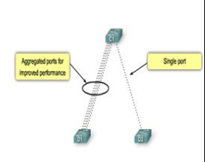
- PoE and Layer 3 functionality

- Power over Ethernet (PoE) allows the switch to deliver power to a device over the existing Ethernet cabling.PoE allows you more flexibility when installing wireless access points and IP phones because you can install them anywhere you can run an Ethernet cable.

- Switch features in hierarchical network
- Access Layer switch features
Access layer switches facilitate the connection of end node devices to the network.
. Switch features in the access layer:
- Port security
- VLANs
- Fast Ethernet/Gigabit Ethernet
- Power over Ethernet (PoE)
- Link aggregation

Port security: allows the switch to decide how many or what specific devices are allowed to connect to the switch.It is an important first line of defense for a network.
VLANs: Access layer switches allow you to set the VLANs for the end node devices on your network.Voice traffic is typically given a separate VLAN. In this way, voice traffic can be supported with more bandwidth, more redundant connections, and improved security.
Port speed: Fast Ethernet allows up to 100 Mb/s of traffic per switch port. Gigabit Ethernet allows up to 1000 Mb/s of traffic per switch port.Fast Ethernet is adequate for IP telephony and data traffic on most business networks.Gigabit Ethernet allows allows for much more efficient data transfers, enabling users to be more productive.

PoE: It should only be considered when voice convergence is required or wireless access points are being implemented, and power is difficult or expensive to run to the desired location.Link aggregation: Access layer switches take advantage of link aggregation when aggregating bandwidth up to distribution layer.

QoS: In a converged network supporting voice, video and data network traffic, access layer switches need to support QoS to maintain the prioritization of traffic.Cisco IP phones are types of equipment that are found at the access layer. QoS needs to be enabled on access layer switches so that voice traffic the IP phone has priority over, for example, data traffic.
- Distribution Layer switch features
Distribution Layer Switch FeaturesDistribution layer switches collect the data from all the access layer switches and forward it to the core layer switches.They need to support features such as
- Layer 3 support
- High forwarding rate
- Gigabit Ethernet/ 10 Gigabit Ethernet
- Redundant components
- Security policies/Access Control Lists
- Link Aggregation
- Quality of Service (QoS)

- Support Layer 3 functions: Distribution layer switches provides the inter-VLAN routing functions so that one VLAN can communicate with another on the network.
- Security Policies: Access lists are used to control how traffic flows through the network.This inspection is performed at the distribution layer, because the switches at this layer typically have the processing capability to handle the additional load, and it also simplifies the use of ACLs.
- Quality of Service: The distribution layer switches need to support QoS to maintain the prioritization of traffic coming from the access layer switches that have implemented QoS.Priority policies ensure that audio and video communications are guaranteed adequate bandwidth to maintain an acceptable quality of service.
- Redundancy: It is important that distribution switches support redundancy for adequate availability.Loss of a distribution layer switch could have significant impact on the rest of the network because all access layer traffic passes through the distribution layer switches
- Link aggregation: Typically, access layer switches use multiple links to connect to a distribution layer switch to ensure adequate bandwidth to accommodate the traffic generated on the access layer, and provide fault tolerance in case a link is lost.Because distribution layer switches accept incoming traffic from multiple access layer switches, they need to be able to forward all of that traffic as fast as possible to the core layer switches.Distribution layer switches also need high-bandwidth aggregated links back to the core layer switches.
- Core Layer switch feature

The core layer of a hierarchical topology is the high-speed backbone of the network and requires switches that can handle very high forwarding rates. They need to support features such as
- Layer 3 support
- High forwarding rate
- Gigabit Ethernet/ 10 Gigabit Ethernet
- Redundant components
- Security policies/Access Control Lists
- Link Aggregation
- Quality of Service (QoS)

- Link Aggregation: The core layer also needs to ensure adequate bandwidth coming into the core from the distribution layer switches. Core layer switches should have support for aggregated 10GbE connections, which is currently the fastest available Ethernet connectivity option
- Redundancy: Layer 3 redundancy typically has a faster convergence than Layer 2 redundancy in the event of hardware failure. You want to ensure that your core layer switches support Layer 3 functions .Also, look for core layer switches that support additional hardware redundancy features like redundant power supplies that can be swapped while the switch continues to operate.
- QoS: An important services provided by core layer switches. At the core and network edge, mission-critical and time-sensitive traffic such as voice should receive higher QoS guarantees than less time-sensitive traffic such as file transfers.

- Switches for small and medium sized business.
Cisco has seven switch product lines. Each product line offers different characteristics and features, allowing you to find the right switch to meet the functional requirements of your network.
Feature of catalyst Switches
The Cisco switch product lines are:
Catalyst Express 500
Catalyst 2960
Catalyst 3560
Catalyst 3750
Catalyst 4500
Catalyst 4900
Catalyst 6500
Learning Outcome 1.3: Describe switched Environment

- Switching as a general Concept
- Ingress port
The decision on how a switch forwards traffic is made in relation to the flow of that traffic. The term ingress is used to describe a frame entering a device on a specific port. The term egress is used to describe frames leaving the device through a particular port
- Destination Address.
When a switch makes a decision, it is based on the ingress port and the destination address of the message

Switch Mac Address Table

Dynamically Populating a Switch MAC Address Table
Switches use MAC addresses to direct network communications through the switch to the appropriate outbound port toward the destination. A switch is made up of integrated circuits and accompanying software that controls the data paths through the switch. For a switch to know which port to use to transmit a frame, it must first learn which devices exist on each port. As the switch learns the relationship of ports to devices, it builds a table called a MAC address table, or content addressable memory (CAM) table. CAM is a special type of memory used in high-speed searching applications.
LAN switches determine how to handle incoming data frames by maintaining the MAC address table. A switch builds its MAC address table by recording the MAC address of each device connected to each of its ports. The switch uses the information in the MAC address table to send frames destined for a specific device out the port, which has been assigned to that device.
An easy way to remember how a switch operates is the following saying: A switch learns on “source” and forwards based on “destination.” This means that a switch populates the MAC address table based on source MAC addresses. As frames enter the switch, the switch “learns” the source MAC address of the received frame and adds the MAC address to the MAC address table or refreshes the age timer of an existing MAC address table entry.
To forward the frame, the switch examines the destination MAC address and compares it to addresses found in the MAC address table. If the address is in the table, the frame is forwarded out the port associated with the MAC address in the table. When the destination MAC address is not found in the MAC address table, the switch forwards the frame out of all ports (flooding) except for the ingress port of the frame. In networks with multiple interconnected switches, the MAC address table contains multiple MAC addresses for a single port connected to the other switches.
The following steps describe the process of building the MAC address table:
Step 1. The switch receives a frame from PC 1 on Port 1
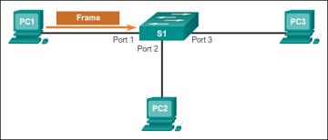
Building a MAC Address Table: PC1 Sends Frame to Port 1
Step 2. The switch examines the source MAC address and compares it to the MAC address table.
- If the address is not in the MAC address table, it associates the source MAC address of PC 1 with the ingress port (Port 1) in the MAC address table
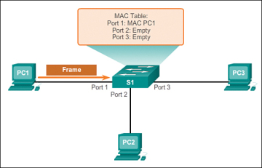
Building a MAC Address Table: S1 Adds MAC Address Heard Through Port 1
- If the MAC address table already has an entry for that source address, it resets the aging timer. An entry for a MAC address is typically kept for five minutes.
Step 3. After the switch has recorded the source address information, the switch examines the destination MAC address.
- If the destination address is not in the MAC table or if it’s a broadcast MAC address, as indicated by all Fs, the switch floods the frame to all ports, except the ingress port
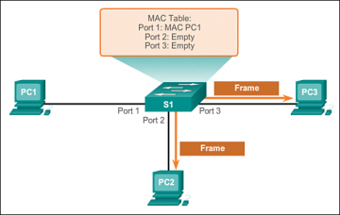
Building a MAC Address Table: S1 Broadcasts the Frame
Step 4. The destination device (PC 3) replies to the frame with a unicast frame addressed to PC 1
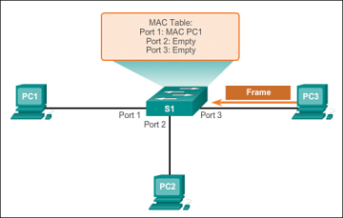
Building a MAC Address Table: PC3 Sends a Reply Frame
Step 5. The switch enters the source MAC address of PC 3 and the port number of the ingress port into the address table. The destination address of the frame and its associated egress port is found in the MAC address table
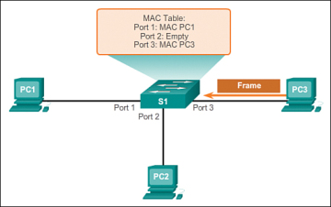
Building a MAC Address Table: S1 Adds the MAC Address for PC3
Step 6. The switch can now forward frames between these source and destination devices without flooding because it has entries in the address table that identify the associated ports
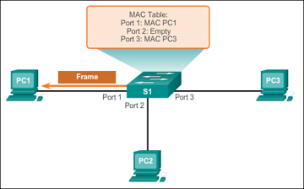
Building a MAC Address Table: S1 Sends the Frame to Port 1

Switch packet Forwarding Methods ()

•Store and forward switching
Store-and-forward switching means that the LAN switch copies each complete frame into the
switch memory buffers and computes a cyclic redundancy check (CRC) for errors.
•Cut-through switching
With cut-through switching, the LAN switch copies into its memory only the destination MAC
address, which is located in the first 6 bytes of the frame following the preamble.
A cut-through switch reduces delay because the switch begins to forward the frame as soon as it reads the destination MAC address and determines the outgoing switch port.

Switching Domains
Two commonly misunderstood terms used with switching are collision domains and broadcast domains. This section tries to explain these two important concepts that affect LAN performance.

Collision Domains
In hub-based Ethernet segments, network devices compete for the medium, because devices must take turns when transmitting. The network segments that share the same bandwidth between devices are known as collision domains, because when two or more devices within that segment try to communicate at the same time, collisions may occur.
It is possible, however, to use networking devices such as switches, which operate at the data link layer of the OSI model to divide a network into segments and reduce the number of devices that compete for bandwidth. Each port on a switch is a new segment because the devices plugged into the ports do not compete with each other for bandwidth. The result is that each port represents a new collision domain. More bandwidth is available to the devices on a segment, and collisions in one collision domain do not interfere with the other segments. This is also known as microsegmentation.
As shown in the Figure , each switch port connects to a single PC or server, and each switch port represents a separate collision domain.
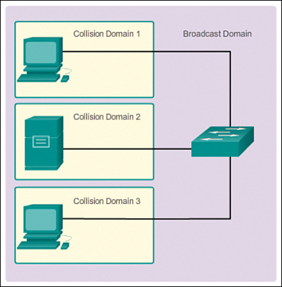
Figure Collision Domains

Broadcast Domains (1.2.2.2)
Although switches filter most frames based on MAC addresses, they do not filter broadcast frames. For other switches on the LAN to receive broadcast frames, switches must overflow (flood) these frames out all ports. A collection of interconnected switches forms a single broadcast domain. A network layer device, such as a router, can divide a Layer 2 broadcast domain. Routers are used to segment both collision and broadcast domains.
When a device sends a Layer 2 broadcast, the destination MAC address in the frame is set to all binary ones. A frame with a destination MAC address of all binary ones is received by all devices in the broadcast domain.
The Layer 2 broadcast domain is referred to as the MAC broadcast domain. The MAC broadcast domain consists of all devices on the LAN that receive broadcast frames from a host.
Broadcast Domains
Go to the online curriculum, and click Play to see this in the first half of the animation.
Watch how a switch broadcasts a frame out all ports except the port that received the frame.
When a switch receives a broadcast frame, the switch forwards the frame out each of the switch ports, except the ingress port where the broadcast frame was received. Each device connected to the switch receives a copy of the broadcast frame and processes it, as shown in the top broadcast domain in . Broadcasts are sometimes necessary for initially locating other devices and network services, but they also reduce network efficiency. Network bandwidth is used to propagate the broadcast traffic. Too many broadcasts and a heavy traffic load on a network can result in congestion: a slowdown in the network performance.
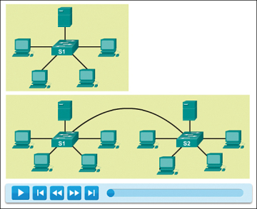
F Broadcast Domains
When two switches are connected together, the broadcast domain is increased, as seen in the second (bottom) broadcast domain. In this case, a broadcast frame is forwarded to all connected ports on switch S1. Switch S1 is connected to switch S2. The frame is then also propagated to all devices connected to switch S2.

Alleviating Network Congestion
LAN switches have special characteristics that make them effective at alleviating network congestion. First, they allow the segmentation of a LAN into separate collision domains. Each port of the switch represents a separate collision domain and provides the full bandwidth to the device or devices that are connected to that port.
Second, they provide full-duplex communication between devices. A full-duplex connection can carry transmitted and received signals at the same time. Full-duplex connections have dramatically increased LAN network performance and are required for 1 Gb/s Ethernet speeds and higher.
Switches interconnect LAN segments (collision domains), use a table of MAC addresses to determine the segment to which the frame is to be sent, and can lessen or eliminate collisions entirely. Table 1-2 shows some important characteristics of switches that contribute to alleviating network congestion.

Table 1-2 Switch Characteristics That Help alleviate Congestion
Characteristic | Explanation
High port density | Switches have high-port densities: 24- and 48-port switches are often just 1 rack unit (1.75 inches) in height and operate at speeds of 100 Mb/s, 1 Gb/s, and 10 Gb/s. Large enterprise switches may support hundreds of ports.
Large frame buffers | The ability to store more received frames before having to start dropping them is useful, particularly when there may be congested ports to servers or other parts of the network.
Port speed | Depending on the cost of a switch, it may be possible to support a mixture of speeds. Ports of 100 Mb/s and 1 or 10 Gb/s are common. (100 Gb/s is also possible.)
Fast internal switching | Having fast internal forwarding capabilities allows high performance. The method that is used may be a fast internal bus or shared memory, which affects the overall performance of the switch.
Low per-port cost | Switches provide high-port density at a lower cost. For this reason, LAN switches can accommodate network designs featuring fewer users per segment, therefore, increasing the average available bandwidth per user.
LU2: Conduct site survey

Learning Outcome 2.1 Analyze facilities and existing networks
Content/Topic 1: Introduction to Site Planning process
- site survey definition
A site survey is the evaluation that needs to take place before the installation of a cell signal booster.
- Purpose of site survey:

- Gather information about the design

- Gather information about the cost of the work

- Determination of precise location of installations.(At which level of the house the system will be installed to be used effectively)
- Determination of best orientation of the site and location of obstacles

- Planning a network installation
This topic provides practical advice to help address the needs of organizations that have a network and are in the process of upgrading it. The article should also be useful to organizations installing a network for the first time.
Here are some ideas to help you start the process:
1.Consider Usage Requirements
Determine the number of people that will be using the network to get a rough idea of the computers and peripherals it must support.
2. Gather Input
Start by defining the requirements of each group and determine the relative costs of incorporating the different requirements into the network plan. This may be in terms of money or time saved.
3. Plan for the future
As you think about expansion, identify any plans that might affect your network needs (e.g. new staff or volunteers, office expansion, remote working, or the installation of new software packages).
4. Decide who will manage the network
As your network solution becomes more defined, you will need to decide whether you have the resources in-house to install and maintain it yourself or whether you require a consultant or external company to handle it
5. Security Issues.
Ensure you build security features into your network plan to protect your organizations most important asset - its information. Common network security precautions include passwords, virus protection, an external firewall and data encryption.
6. Information Management
Consider how to manage information on your server so that users can easily find what they need. Create standardized naming conventions for files on the server and establish rules for the creation of new files and folders.
7. Remote Access
If some staff members travel frequently or work from locations outside your office, you may want to build remote access capabilities into your network. This can be done through remote dial-in, or securely over the Internet using a VPN
8.Staff Training
While working with a network is relatively simple, it may demand that employees adopt new habits. A training program will enable workers to take full advantage of your network's timesaving and productivity enhancing features.
9. Network pre-installation checklist
This checklist of questions will help you cover the main areas when it comes to planning and installing a new or upgraded network.
8. Network hardware requirements
- What other devices will your network support (e.g. back-up devices, Uninterruptible Power Supplies, Network printers, etc.)?
o you have enough network points for these network devices?
9. Network design
• What network topology will you use
• Do all workstations have the correct Network interface cards (NICs) to support this technology?
10. Do you have resources allocated for the following areas (e.g., consultants, in-house IT staff etc)?
o Network installation
o Cable installation
o Network technical support
o Network management
o Network security
o Network maintenance
o Training
- Site Planning process
Two process
- Initial environment evaluation
- Selection of router deployment
Initial environment evaluation
The term “Initial Environmental Evaluation” refers to a limited environmental study which describes a proposed project, the environment surrounding that project, and identifies and evaluates any likely impacts on that environment.
Selection of router deployment: Restrict routers to hosts where port 80/443 is available and not being consumed by another service.
Content/Topic 2: Evaluation of network Environment
- Types of Site Surveys
There are 2 types of surveys:
-Physical and
-Predictive.

  - Physical Survey:

- Passive Survey
A passive survey is what you described: an analysis of the possible affects that a physical environment may have on a theoretical wireless network. This is performed with a listen-only mode.

These can be accomplished with a passive survey:
- Identify rogues
- Locate RF trouble zones quickly
- Validate final RF setting
- Perform initial surveys

- Active Survey

An active site survey uses tools to discover the coverage and problems of an existing and operational wireless network. Measuring of signal frame strength.

  - Predictive Surveys
Predictive surveys are performed with a software program. The program uses the information about the coverage area to perform AP placements based on RF algorithms. These surveys are typically void of any type of field measurements.
The best times to incorporate a predictive survey include:
- When the deployment environment has not yet been built.
- In order to obtain a budgetary environment for WLAN-related hardware.
- When roaming requirements are less stringent.

Predictive Surveys
Predictive surveys are performed with a software program. The program uses the information about the coverage area to perform AP placements based on RF algorithms. These surveys are typically void of any type of field measurements.
The best times to incorporate a predictive survey include:
- When the deployment environment has not yet been built.
- In order to obtain a budgetary environment for WLAN-related hardware.
- When roaming requirements are less stringent.

Learning Outcome 2.2: Identify components, devices ,tools, connectors and media

Hardware Devices:

- Internetworking Devices:

    - Router : A network device that links different networks
    - Multilayer switches: Multilayer Switching (MLS) is Ethernet-based routing switch technology by Cisco that provides Layer 3 (L3) switching in conjunction with existing routers
    - Wireless Router : A wireless router is a device that performs the functions of a router and also includes the functions of a wireless access point

- Networking Access Devices: A Network Access Device (or NAD) is an electronic device that automatically connects a user to a preferred network.
- Networking Access Devices are:

    - Switches
    - Wireless Access Point

- Security Devices:
Firewalls: A firewall is a system designed to prevent unauthorized access to or from a private network. You can implement a firewall in either hardware or software form, or a combination of both. Firewalls prevent unauthorized internet users from accessing private networks connected to the internet, especially intranets.

- End Devices:
- Computers(Work stations, laptops,file servers,web servers)
- Network Printers
- Security Cameras
- Mobile Handheld Devices(Smartphones,Tablets,PDAs)

-  Hardware Components:
- NIC
- Wireless Adapter cards

- Troubleshooting Tools:

10. Ping
The most commonly used network tool is the ping utility. This utility is used to provide a basic connectivity test between the requesting host and a destination host. This is done by using the Internet Control Message Protocol (ICMP) which has the ability to send an echo packet to a destination host and a mechanism to listen for a response from this host. Simply stated, if the requesting host receives a response from the destination host, this host is reachable. This utility is commonly used to provide a basic picture of where a specific networking problem may exist. For example, if an Internet connection is down at an office, the ping utility can be used to figure out whether the problem exists within the office or within the network of the Internet provider. Figure 1 below shows an example of the ping utility being used to obtain the reachability status of the locally connected router.

Figure 1: Ping utility

9. Tracert/traceroute
Typically, once the ping utility has been used to determine basic connectivity, the tracert/traceroute utility can used to determine more specific information about the path to the destination host including the route the packet takes and the response time of these intermediate hosts. Figure 2 below shows an example of the tracert utility being used to find the path from a host inside an office to www.google.com. The tracert utility and traceroute utilities perform the same function but operate on different operating systems, Tracert for Windows machines and traceroute for Linux/*nix based machines.
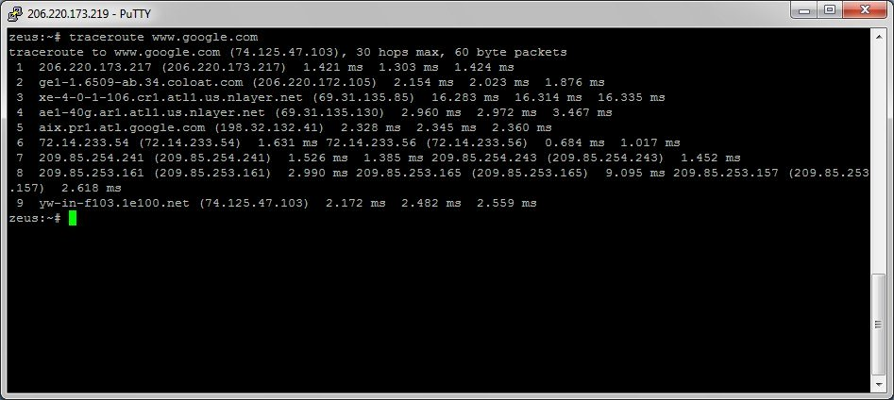
Figure 2: Tracert/traceroute utility

8. Ipconfig/ifconfig
One of the most important things that must be completed when troubleshooting a networking issue is to find out the specific IP configuration of the variously affected hosts. Sometimes this information is already known when addressing is configured statically, but when a dynamic addressing method is used, the IP address of each host can potentially change often. The utilities that can be used to find out this IP configuration information include the ipconfig utility on Windows machines and the ifconfig utility on Linux/*nix based machines. Figure 3 below shows an example of the ifconfig utility showing the IP configuration information of a queries host.
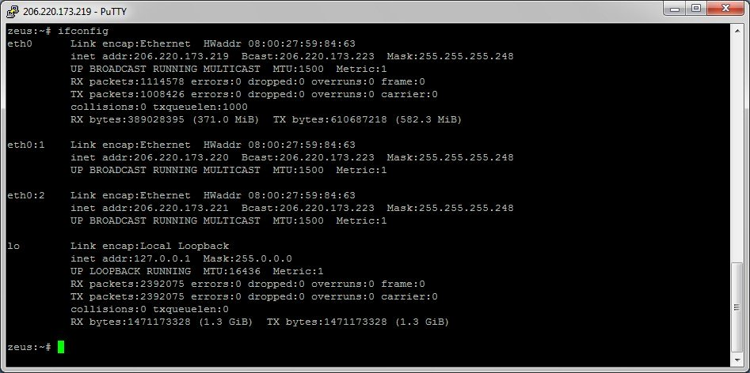
Figure 3: Ifconfig utility

7. Nslookup
Some of the most common networking issues revolve around issues with Dynamic Name System (DNS) address resolution issues.
DNS is used by everyone using the Internet to resolve commonly known domain names (i.e. google.com) to commonly unknown IP addresses (i.e. 74.125.115.147).
The nslookup utility can be used to lookup the specific IP address(es) associated with a domain name. If this utility is unable to resolve this information, there is a DNS issue. Along with simple lookup,
the nslookup utility is able to query specific DNS servers to determine an issue with the default DNS servers configured on a host
. Figure 4 below shows an example of how the nslookup utility can be used to query the associated IP address information.
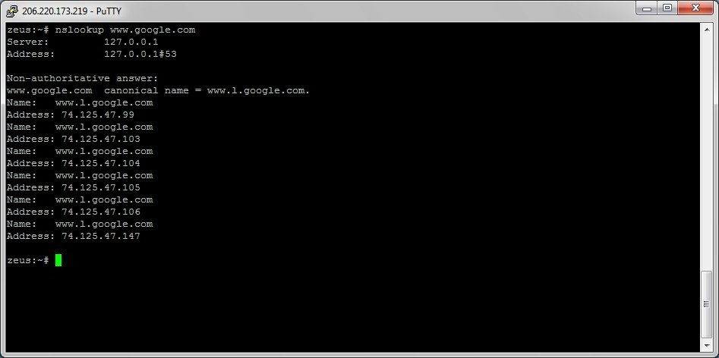
Figure 4: Nslookup utility

6. Netstat
Often, one of the things that are required to be figured out is the current state of the active network connections on a host. This is very important information to find for a variety of reasons.
For example, when verifying the status of a listening port on a host or to check and see what remote hosts are connected to a local host on a specific port.
It is also possible to use the netstat utility to determine which services on a host that is associated with specific active ports.
Figure 5 below shows an example of the netstat utility being used to display the currently active ports on a Linux machine.
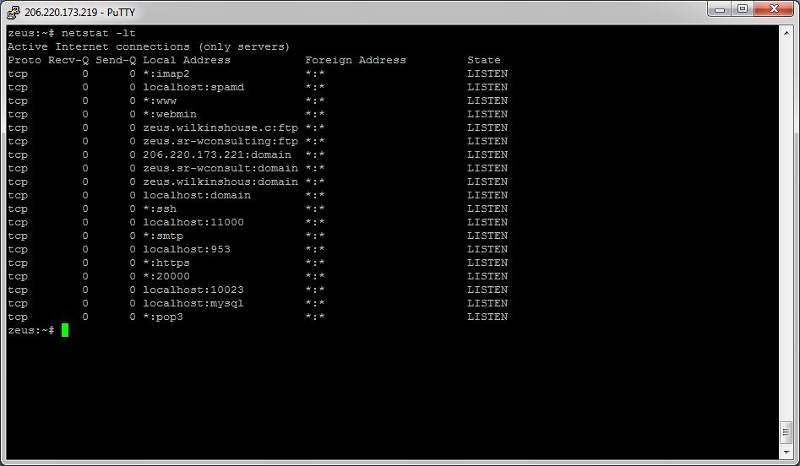
Figure 5: Netstat utility

5. PuTTY/Tera Term
When connecting to a variety of different types of equipment, a telnet, SSH or serial client is required; when this is required both the puTTY and Tera Term programs are able to provide these functionalities. The selection of one over the other is strictly a personal preference. Figures 6 and 7 below show both puTTY and Tera Term being used to connect to a host via SSH.
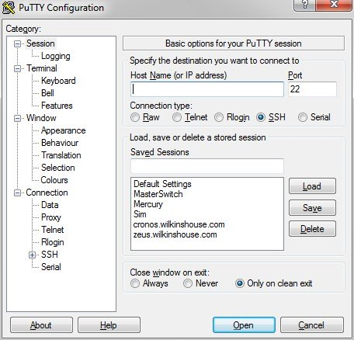
Figure 6: PuTTY
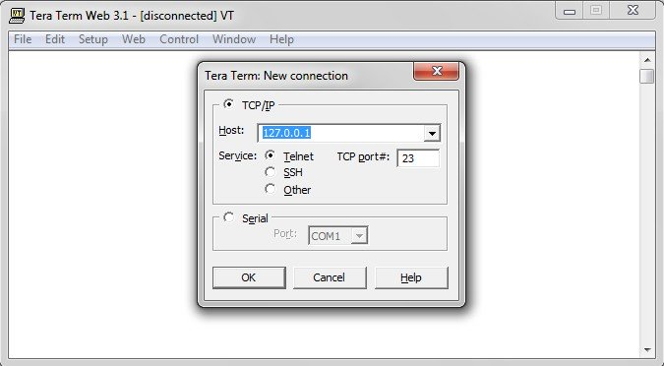
Figure 7: Tera Term

4. Subnet and IP Calculator
.These can be used to unsure a correct IP address selection and with this a correct IP address configuration.
Two of the more commonly used free IP calculators include Wildpackets (Bitcricket) Network Calculator and Solarwinds Advanced Subnet Calculator which can be found at the links below.
http://www.bitcricket.com/downloads/IPCalculator.msi
http://downloads.solarwinds.com/solarwinds/Release/FreeTool/SolarWinds-Subnet-Calculator.zip
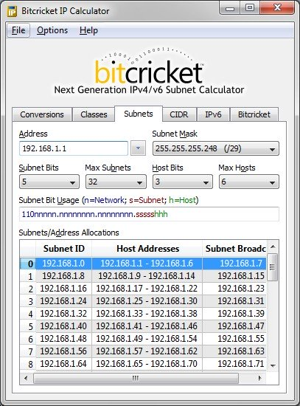
Figure 8: Subnet calculator

3. Speedtest.net/pingtest.net
A very easy test that can be used to both determine the Internet bandwidth available to a specific host and to determine the quality of an Internet connection is the use of the tools available at the speedtest.net and pingtest.net websites. The speedtest.net site provides the ability to determine the amount of bandwidth that is available to a specific host at a specific point in time; this is often a good tool to use when measuring how long it is going to take to upload or download information from a local to remote host. This measurement can also be used to determine whether the connection is offering the amount of bandwidth that was purchased from the Internet provider; keep in mind however that some amount of bandwidth difference is expected between the quoted bandwidth purchased and the measured bandwidth. The pingtest.net website is used to determine the quality of the connection by measuring the ping response times and jitter amounts over a short period of time. This information can be used to determine a likelihood of how well the measured connection will deal with certain types of high demand traffic like Voice over IP (VoIP) or gaming. Figure 9 and 10 below show example output from both of these sites.
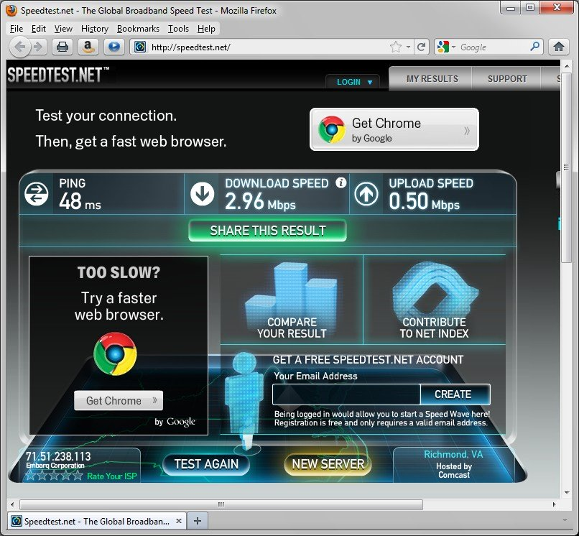
Figure 9: Speedtest
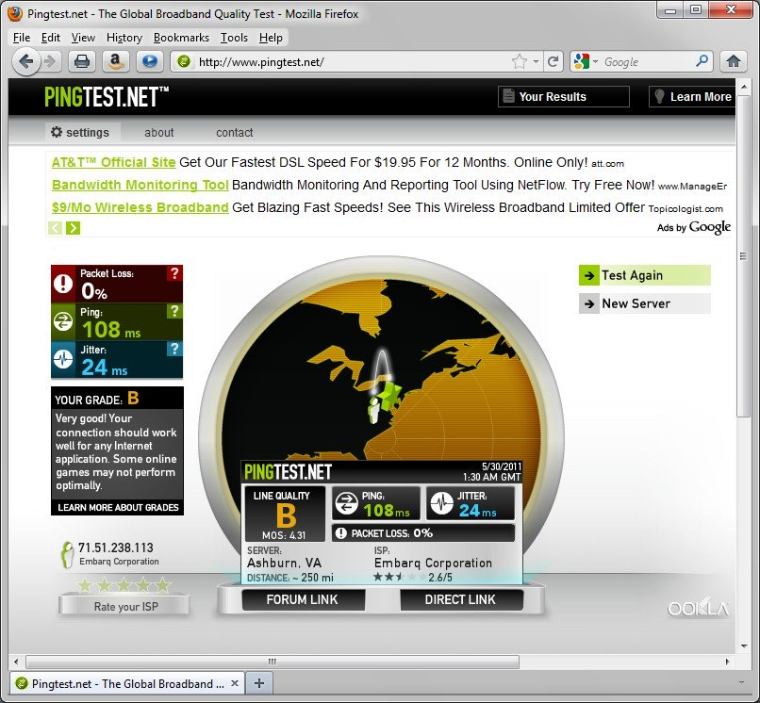
Figure 10: Pingtest

2. Pathping/mtr
In an effort to take advantage of the benefits of both the ping and tracert/traceroute commands, the pathping and mtr utilities were developed. Both of these tools take the functionality and information that can be obtained from these types of tools and provide a more detailed single picture of the path characteristics from a specific host to a specific destination. Figure 11 and 12 below show examples of these two tools and what information they provide.
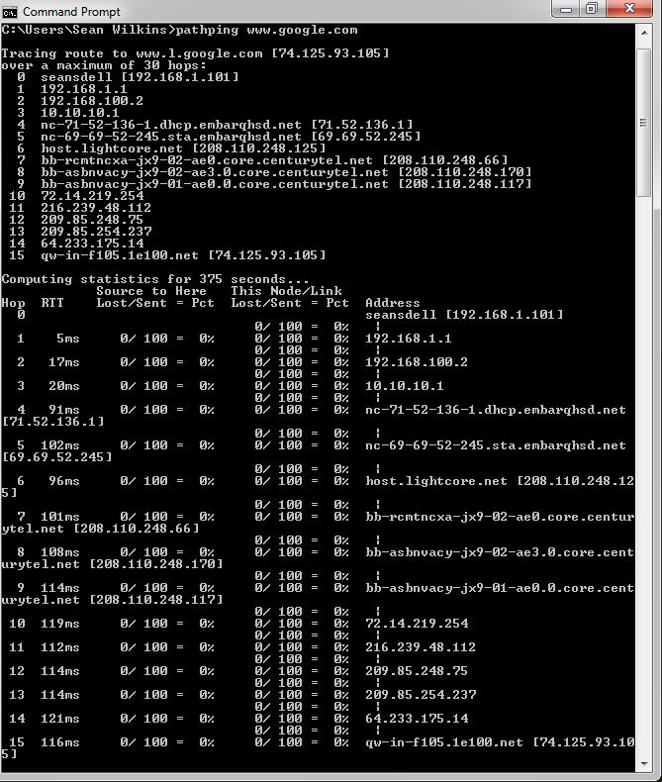
Figure 11: Pathping
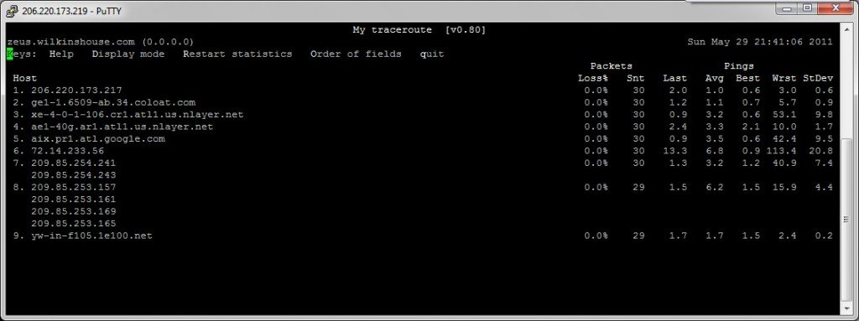
Figure 12: Mtr

1. Route
The last of the tools covered in this article is the route utility. This utility is used to display the current status of the routing table on a host. While the use of the route utility is limited in common situations where the host only has a single IP address with a single gateway, it is vital in other situations where multiple IP address and multiple gateways are available. Figure 13 below shows an example of the route utility being used on a Windows machine.
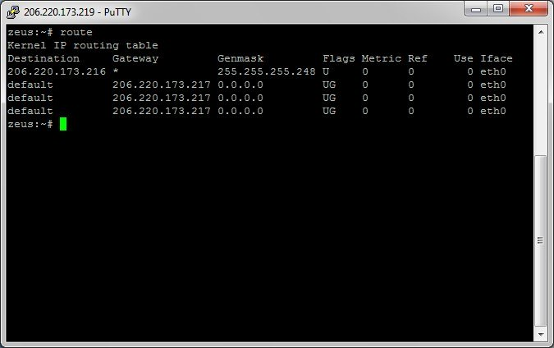
Learning unit 3: Describe Basic switching concepts and configuration
Learning Outcome 3. 1 Introduce Ethernet/802.3 LANs
3.1.1 The key elements of Ethernet/ 802.3 Networks
What is the standard for Ethernet?
IEEE Standard 802.3
The Institute for Electrical and Electronic Engineers developed an Ethernet standard known as IEEE Standard 802.3.
Ethernet describes a technology for cabled data networks that connect software and/or hardware with each other. This mostly takes place via LAN cables, which is why Ethernet is also sometimes referred to as LAN technology. In this way, Ethernet enables data exchanges between end devices. These could be computers, printers, servers, routers, or others. When combined into a local network, these devices establish connections via the Ethernet protocol and can exchange data packages with one another. The current and most widely distributed protocol is IEEE 802.3. This standard defines rules for configuring an Ethernet network and also specifies how the elements in an Ethernet network interact with one another.

While the first version of the technology only had a speed of 3 megabits per second, Ethernet protocol today enables speeds of up to 1.000 megabits per second
.Which networking technology is based on the IEEE 802.3 standard?
Ethernet
Ethernet is a family of wired computer networking technologies commonly used in local area networks (LAN), metropolitan area networks (MAN) and wide area networks (WAN). It was commercially introduced in 1980 and first standardized in 1983 as IEEE 802.3.

Why IEEE 802 standards are important?
It was formed in 1980 in order to standardize network protocols and provide a path to make compatible devices across numerous industries. Without these standards, equipment suppliers could manufacture network hardware that would only connect to certain computers.

- Media Access Control In Ethernet
.
- Carrier sense Multiple access collusion detection (CSMA/CD)
Carrier Sense Multiple Access with Collision Detection (CSMA/CD) is the LAN access method
used in Ethernet. When a device wants to gain access to the network, it checks to see if the
network is free. If the network is not free, the device waits a random amount of time before
retrying. If the network is free and two devices access the line at exactly the same time, their
signals collide. When the collision is detected, they both back off and wait a random amount oftime before retrying.
Ethernet communications
Unicast: from one source to one destination, traffic, many streams of IP packets that move across networks flow from a single point, such as a website server, to a single endpoint such as a client PC. This is the most common form of information transference on networks. i.e. One-to-One

Example:
1) Browsing a website. (Webserver is the sender and your computer is the receiver.)
2) Downloading a file from a FTP Server. (FTP Server is the sender and your computer is the
receiver.)
- Broadcast: from one source to all possible destinations i.e. One-to-All
Unicast is a type of communication where data is sent from one computer to another computer.
In Unicast type of communication, there is only one sender, and one receiver.
Example:
1) Browsing a website. (Webserver is the sender and your computer is the receiver.)
2) Downloading a file from a FTP Server. (FTP Server is the sender and your computer is the
receiver.)
- Multicast: from one source to multiple destinations stating an interest in receiving the traffic i.e. One-to-Many. In Multicast, the sender transmit only one copy of data and it is delivered and/or processed tomany devices who are interested
in that traffic. Multicast group to receive the traffic. IP Multicast Groups are identified by Multicast IP Addresses (IPv4 Class D. Addresses 224-239 first octet range)
- Broadcast is a type of communication where data is sent from one computer once and a copy of that data will be forwarded to all the devices. I t is a one to all communication
In Broadcast, there is only one sender and the data is sent only once. But the Broadcast data is delivered to all connected devices.

For example, a radio station broadcasts a signal to many listeners, and digital TV subscribers receive a signal that is broadcast by their TV provider.

Switches by design will forward the broadcast traffic and Routers by design will drop the broadcast traffic. In other words, Routers will not allow a broadcast from one LAN to cross the Router and reach another Network Segment. The primary function of a Router is to divide a big Broadcast domain to multiple smaller Broadcast domain
Preamble and start frame Delimiter fields
The primary fields in the Ethernet frame are: Preamble and Start Frame Delimiter Fields:
The Preamble (7 bytes) and Start Frame Delimiter (SFD), also called the Start of Frame (1
byte), fields are used for synchronization between the sending and receiving devices.

Ethernet frame fields IEEE 802.3

What is the Ethernet frame?
An Ethernet frame is a piece of data along with the information that is required to transport and deliver that piece of data. In networking reference models, such as; OSI Seven Layers model and TCP/IP, the Ethernet frame is defined in the Data link layer

- Preamble – informs the receiving system that a frame is starting and enables synchronization.

The preamble field is 7 bytes long. It contains a string of 7 bytes. Each byte alternatively stores 1 and 0 to make the pattern '10101010'. Preamble bytes help the receiving device to identify the beginning of an Ethernet frame. When a device receives 7 continuous bytes of the same pattern (10101010), it assumes that the incoming data is an Ethernet frame and it locks the incoming bit-stream.
- The SFD field
The SFD (Start Frame Delimiter) field is 1 byte long. It contains a string of 1 byte. This byte also stores the same pattern, except the last bit. In the last bit, it stores 1 instead of the 0. The following image shows both fields with their related bytes respectively.
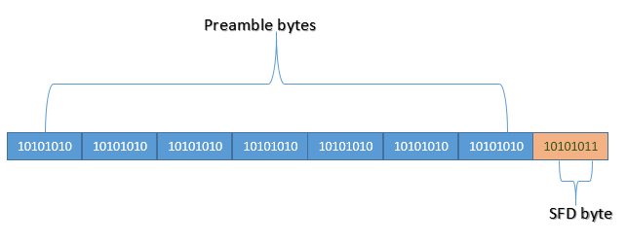
The Preamble (7 bytes) and Start Frame Delimiter (SFD), also called the Start of Frame (1 byte), fields are used for synchronization between the sending and receiving devices
What is synchronization?
Only one thread can own a monitor at a given time. When a thread acquires
lock, it is said to have entered the monitor. All other threads attempting to
enter the locked monitor will be suspended until the first thread exits the monitor.
.
- Destination Address – This is 6-Byte field which contains the MAC address of machine for which data is destined
- Source Address :This is a 6-Byte field which contains the MAC address of source machine.
- Length : Length is a 2-Byte field, which indicates the length of entire Ethernet frame.
- Frame check sequence field:A frame check sequence (FCS) refers to the extra error-detecting code.
Duplex settings
- Half duplex
Half duplex communication restricts a node to either transmit or receive at a time but not
perform both actions concurrently. Nodes sharing a half duplex connection are operating in the
same collision domain.
- Full duplex
Refers to the transmission of data in two directions simultaneously. For example, a telephone is
a full-duplex device because both parties can talk at once.
Command to show if ports are full/half duplex
# show interface status
or # show int fa0/1
•Switch port settings
Auto option setting
Auto-negotiation is an optional function of the IEEE 802.3u Fast Ethernet standard that enables devices to automatically exchange information over a link about speed and duplex abilities.
.
Full option setting
Switch-B> (enable) set port duplex 1/1 full
Half option setting
Switch-B> (enable) set port duplex 1/1 half
- MAC addressing and switch MAC address tables
- MAC addressing
A MAC address is a hardware identification number that uniquely identifies each device on a network. For this reason, MAC addresses are made up of six two-digit hexadecimal numbers, separated by colons. For example, an Ethernet card may have a MAC address of 00:0d:83:b1:c0:8e

Types of MAC Address
- Unicast – A Unicast addressed frame is only sent out to the interface leading to specific NIC. If the LSB (least significant bit) of first octet of an address is set to zero, the frame is meant to reach only one receiving NIC. MAC Address of source machine is always Unicast
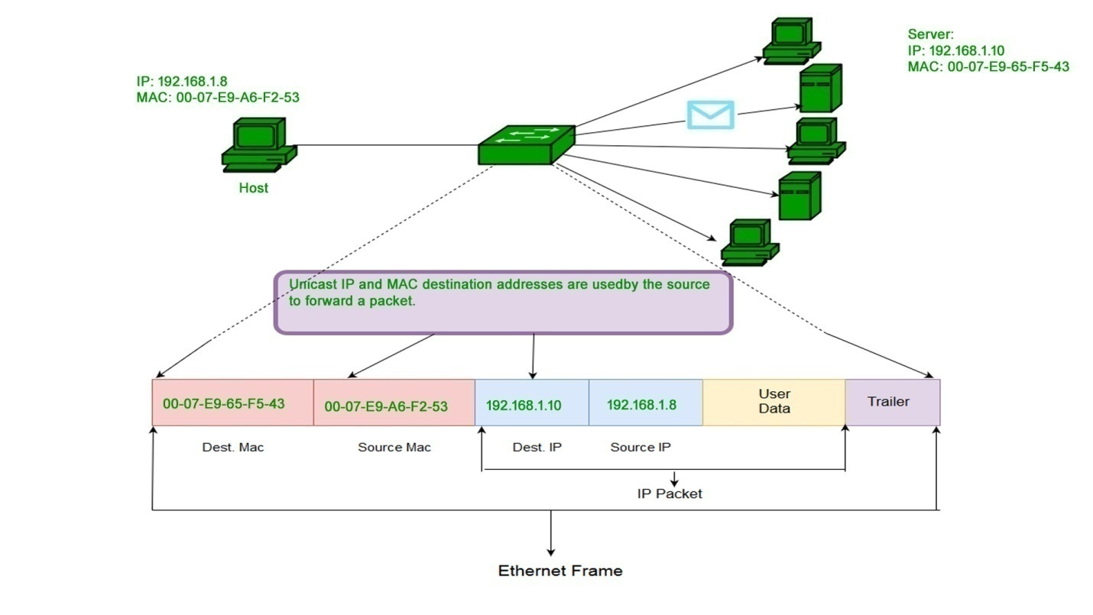
2.Multicast – Multicast address allow the source to send a frame to group of devices. In Layer-2 (Ethernet) Multicast address, LSB (least significant bit) of first octet of an address is set to one. IEEE has allocated the address block 01-80-C2-xx-xx-xx (01-80-C2-00-00-00 to 01-80-C2-FF-FF-FF) for group addresses for use by standard protocols
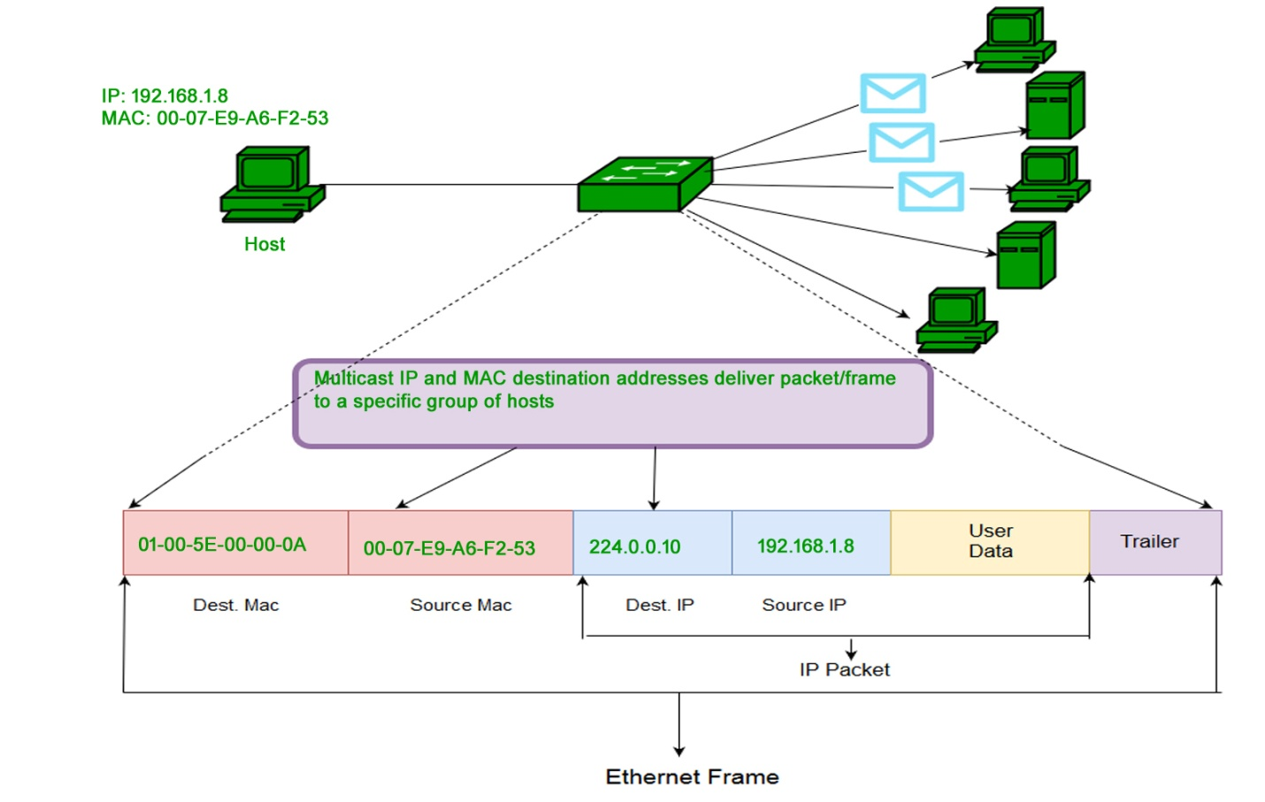
3.Broadcast – Similar to Network Layer, Broadcast is also possible on underlying layer( Data Link Layer). Ethernet frames with ones in all bits of the destination address (FF-FF-FF-FF-FF-FF) are referred as broadcast address. Frames which are destined with MAC address FF-FF-FF-FF-FF-FF will reach to every computer belong to that LAN segment.
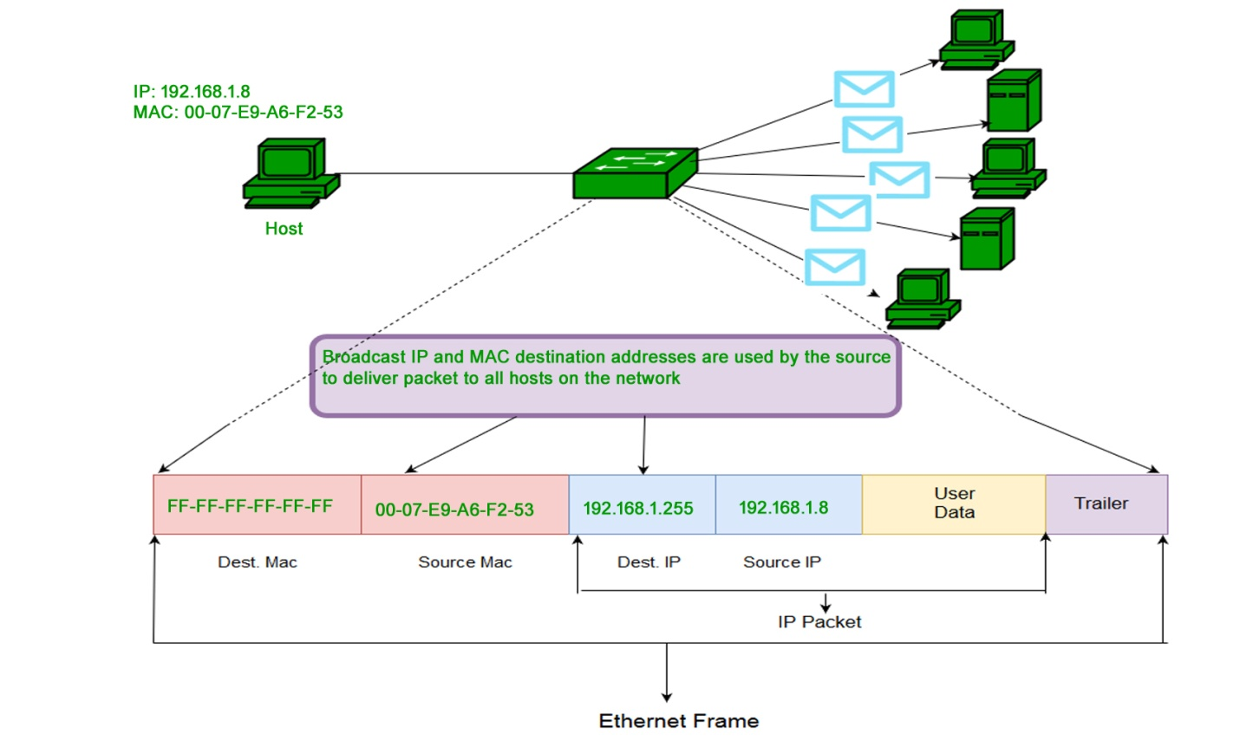
- Switch MAC address tables

Switches use MAC addresses to direct network communications through the switch to the appropriate outbound port toward the destination. A switch is made up of integrated circuits and accompanying software that controls the data paths through the switch. For a switch to know which port to use to transmit a frame, it must first learn which devices exist on each port. As the switch learns the relationship of ports to devices, it builds a table called a MAC address table, or content addressable memory (CAM) table. CAM is a special type of memory used in high-speed searching applications

The switch receives a frame from PC 1 on Port 1
Building a MAC Address Table: PC1 Sends Frame to Port 1
Step 2. The switch examines the source MAC address and compares it to the MAC address table.
- If the address is not in the MAC address table, it associates the source MAC address of PC 1 with the ingress port (Port 1) in the MAC address table
Building a MAC Address Table: S1 Adds MAC Address Heard Through Port 1
- If the MAC address table already has an entry for that source address, it resets the aging timer. An entry for a MAC address is typically kept for five minutes.
Step 3. After the switch has recorded the source address information, the switch examines the destination MAC address.
- If the destination address is not in the MAC table or if it’s a broadcast MAC address, as indicated by all Fs, the switch floods the frame to all ports, except the ingress port
Building a MAC Address Table: S1 Broadcasts the Frame
Step 4. The destination device (PC 3) replies to the frame with a unicast frame addressed to PC 1
Building a MAC Address Table: PC3 Sends a Reply Frame
Step 5. The switch enters the source MAC address of PC 3 and the port number of the ingress port into the address table. The destination address of the frame and its associated egress port is found in the MAC address table .
Building a MAC Address Table: S1 Adds the MAC Address for PC3
Step 6. The switch can now forward frames between these source and destination devices without flooding because it has entries in the address table that identify the associated ports
Building a MAC Address Table: S1 Sends the Frame to Port 1

3.1.2. Design consideration for Ethernet/802.3 Networks
Bandwidth and Throughput
Bandwidth is the maximum amount of data that can travel through a 'channel'. Throughput is
how much data actually does travel through the 'channel' successfully.
•Collusion domains
A collision domain is, as the name implies, a part of a network where packet collisions can
occur. A collision occurs when two devices send a packet at the same time on the shared network
segment. The packets collide and both devices must send the packets again, which reduces
network efficiency.
•Broadcast domains
A broadcast domain is a domain in which a broadcast is forwarded. A broadcast domain contains
all devices that can reach each other at the data link layer (OSI layer 2) by using broadcast. All
ports on a hub or a switch are by default in the same broadcast domain.
All ports on a router are in the different broadcast domains and routers don’t forward broadcasts
from one broadcast domain to another.
•Network latency
Latency Definition. Latency is the amount of time a message takes to traverse a system. In a
computer network, it is an expression of how much time it takes for a packet of data to get from
one designated point to another.
•Network CONGESTION congestion
Network congestion is the situation in which an increase in data transmissions results in a
proportionately smaller increase, or even a reduction, in throughput.
In occurs on shared networks when multiple user contend for access to the same resources
(bandwidth, buffers and queues). When the number of packet sent into the network is within the
limits, almost all packets are delivered, however the traffic load increases beyond the network
capacity. As a result the system starts discarding packets.
- LAN segmentation
LAN segmentation describes the process of dividing single Ethernet segments into multiple
segments. Networks are divided into multiple segments for security and to improve traffic flow
by filtering out packets that are not destined for the segment.
Advantages:
- Performances
- Avoid network congestion
- Bandwidth availability is maximized.
Technologies used:
- Physical segmentation using bridges and routers
- Network switch
- Use of fast Ethernet devices
Learning Outcome 3.2 Describe Forwarding frames using a switch

- Switch packet Forwarding Methods
•Store and forward switching
Store-and-forward switching means that the LAN switch copies each complete frame into the
switch memory buffers and computes a cyclic redundancy check (CRC) for errors.
•Cut-through switching
With cut-through switching, the LAN switch copies into its memory only the destination MAC
address, which is located in the first 6 bytes of the frame following the preamble.
A cut-through switch reduces delay because the switch begins to forward the frame as soon as it
reads the destination MAC address and determines the outgoing switch port.

b
- Symmetric and Asymmetric switching

LAN switching may be classified as symmetric or asymmetric based on the way in which
bandwidth is allocated to the switch ports.
A symmetric switch provides switched connections between ports with the same bandwidth.
An asymmetric LAN switch provides switched connections between ports of unlike bandwidth,such as a combination of 10-Mbps and 100-Mbps ports.
Asymmetric switching enables more bandwidth to be dedicated to the server switch port in order
to prevent a restricted access.

- Port based and Shared memory buffering methods.
During congestion at the port, the switch stores the frame until it transmitted. The memory buffer is the area where the switch store the data.

There are two methods of buffering:-

Port-based Memory Buffering
In port buffering switch gives each Ethernet port with a certain amount of high-speed memory to buffer frames until transmitted. A disadvantage of port buffered memory is the dropping of frames when a port runs out of buffers. It is also possible for a single frame to delay the transmission of all the frames in memory because of a busy destination port. This delay occurs even if the other frames could be transmitted to open destination ports.

Shared Memory Buffering
Some of the earliest Cisco switches use a shared memory design for port buffering. Shared buffering deposits all frames into a common memory buffer that all the ports on the switch share. The amount of buffer memory required by a port dynamically allocated. The frames in the buffer have dynamically connected to the destination port. This allows the packet to receive on one port and then transmitted on another port, without moving it to a different queue.

- Port based and Shared memory buffering
Memory buffering is required on an asymmetric switch. The use of buffers keeps the frames
contiguous between different data rate ports. Memory buffer is the area of memory where the
switch stores the data memory for all ports to use
- Symmetric and asymmetric switching
LAN switching may be classified as symmetric or asymmetric based on the way in which
bandwidth is allocated to the switch ports.
A symmetric switch provides switched connections between ports with the same bandwidth.
An asymmetric LAN switch provides switched connections between ports of unlike bandwidth,
such as a combination of 10-Mbps and 100-Mbps ports.
Asymmetric switching enables more bandwidth to be dedicated to the server switch port in order
to prevent a bottleneck..
• Layer 2 and layer 3 Switching
Layer 2 switches basically do switching only, which means they operate using devices’ MAC
addresses to redirect the data packets from the source port to the destination port.
A Layer 3 switch is exactly the opposite of what a Layer 2 switch does. Layer 2 switches were
not able to route data packets at layer 3. Unlike Layer 2 switches, Layer 3 does routing using IP
addresses. It’s a specialized hardware device used in routing data packets. Layer 3 switches have
fast switching capabilities and they have higher port density.
Learning Outcome 3. 3. Apply Switch management configuration
3.3.1 Navigating command line interface mode
Cisco CLI has different modes (IOS modes) including user EXEC Mode, Privileged EXEC
Mode, Global Configuration Mode.
a. Command line interface
CLI (command-line interface) is the primary user interface used for connecting Cisco devices.
CLI allows you to directly execute IOS commands.
-Device manager
Device Manager provides a graphical representation of a Cisco MDS 9000 Family switch
chassis, a Cisco Nexus 5000 Series switch chassis(framework), or a Cisco Nexus 7000 Series switch framework including the installed switching modules, the supervisor modules, the status of each port within each module, the power supplies, and the fan assemblies.
.Device Manager provides two views:
1. Device View (to perform switch-level configurations) and
2.Summary View (to monitor interfaces on the switch).
- SNMP network management
-Simple Network Management Protocol (SNMP) is network administration tool that allows easy
configuration with just few commands. SNMP is the most popular way to monitor the performance of network devices, including Cisco routers and switches.
It allows also monitoring network devices such as servers, workstations, printers, routers ,bridges, and hubs, as well as services such as Dynamic Host Configuration Protocol (DHCP) or Windows Internet Name Service (WINS).
3.3.2 Using the help facility

Entering a question mark (?) at the CLI prompt displays a list of commands available for each
command mode.
• Context sensitive help
i. Word help
Word help can be used to obtain a list of available commands that begin with a character (or
string of characters) that you have begun to type. To use word help, enter ? immediately after the
character, or characters, in question, without a space.
ii. Command syntax help
Command syntax help can be used to obtain a list of command, keyword, or argument options
that are available based on the syntax you have already entered. To use command syntax help,
enter ? in the place of a keyword or argument.

Help Command Examples
help ver
In this example, the full help information for the ver command is displayed on the screen, which might look something like this: Displays the Windows version.

iii. Console error messages
The system software sends these error messages to the console (and, optionally, to a logging server on another system) during operation. Not all system error messages indicate problems
with your system. Some are purely informational, and others may help diagnose problems with communications lines, internal hardware, or the system software.
3.3.3 The switch boot sequence
After a Cisco switch is powered on, it goes through the following boot sequence:
Step 1. First, the switch loads a power-on self-test (POST) program stored in ROM. POST
checks the CPU subsystem. It tests the CPU, DRAM, and the portion of the flash device that
makes up the flash file system.
Step 2. Next, the switch loads the boot loader software. The boot loader is a small program
stored in ROM and is run immediately after POST successfully completes.
Step 3. The boot loader performs low-level CPU initialization. It initializes the CPU registers
that control where physical memory is mapped, the quantity of memory, and memory speed.
Step 4. The boot loader initializes the flash file system on the system board.
Step 5. Finally, the boot loader locates and loads a default IOS operating system software image
into memory and hands control of the switch over to the IOS.
Basic switch configuration
i. Management interface considerations
- Configure IP connectivity
Beginning in privileged EXEC mode, follow these steps to manually assign IP information to multiple switched virtual interfaces (SVIs):
Command | Purpose
Step  1 | configure  terminal | Enter global configuration mode.
Step  2 | interface  vlan vlan-id | Enter interface configuration mode, and enter the VLAN to which  the IP information is assigned. The VLAN range is 1 to 4094.
Step  3 | ip addressip  address subnet  mask | Enter the IP address and subnet mask.
Step  4 | exit | Return to global configuration mode.
Step  5 | ip default  gatewayip  address | Enter the IP address of the next-hop router interface that is directly  connected to the switch where a default gateway is being  configured. The default gateway receives IP packets with  unresolved destination IP addresses from the switch.  Once the default gateway is configured, the switch has connectivity  to the remote networks with which a host needs to communicate.

Note | When your switch is configured to route with IP, it does not need  to have a default gateway set.
Step  6 | end | Return to privileged EXEC mode.
Step  7 | show interfaces  vlan vlan-id | Verify the configured IP address.
Step  8 | show ip  redirects | Verify the configured default gateway.
Step  9 | copy running  config startup  config | (Optional) Save your entries in the configuration file.
To remove the switch IP address, use the no ip address interface configuration command.
Clearing configuration information
Switch#delete flash:vlan.dat
Delete filename [vlan.dat]?[Enter]
Delete flash:vlan.dat? [confirm] [Enter]
iii. Deleting a stored configuration files
Remove the switch startup configuration file from NVRAM.
Switch#erase startup-config.

3.4.1 Configuring basic switch security:
a. Configure console access
S1#enable
b. Configure Virtual Terminal access
S1#configure terminal
c. Configure EXE Mode password
S1(config)#line console 0
S1(config-line)#password cisco
S1(config-line)#login
S1(config-line)#line vty 0 15
S1(config-line)#password cisco
S1(config-line)#login
S1(config-line)#exit
d. Configure Encrypted Passwords
S1(config)#enable secret class
e. Enable password Recovery
Password recovery is helpful when you turn on a switch or perform a reload and find out that it is
locked. The following way allows to physically performing a password recovery on a Cisco
Catalyst Switch.
Step 1: Connect your PC or terminal into the switch console port with the blue console cable.
Step 2: Open up a Hyperterminal for emulation and set the speed to 9600 baud.
Step 3: Unplug the power cable to the switch.
Step 4:Press and hold the Mode button on the front of the switch and plug the power cable back
into the switch at the same. After the power cable has been plugged in, wait a couple of seconds
and then release the Mode button.
Step 5: Your display on your HyperTerminal should look like this… switch:
Step 6: Enter these commands into the switch
• switch: flash _init
• switch: load_helper
• switch: dir flash:
Directory of flash:
• 13 drwx 192 Mar 01 1993 22:30:48 c2960-mz-124-0.0.53
• 11 -rwx 5825 Mar 01 1993 22:31:59 config.text
• 18 -rwx 720 Mar 01 1993 02:21:30 vlan.da
• switch: rename flash:config.text flash:config.text.old
• switch: boot
Step 7: Once the switch reboots, answer NOto “Would you like to enter system configuration
dialog? [Yes/No]:
Step 8: Get into the privilege prompt.
• Switch>enable
• Switch#rename flash:config.text.old flash:config.text
• Switch#copy flash:config.text system:running-config
• Source filename [config.text]?
• Destination filename [running-config]?
• Press Enter to copy

Configure a Login Banner

A banner is a message presented to a user who is using the Cisco switch.
Banner messages should be used to warn would-be intruders that they are not welcome on your network
There are three kinds of banners namely: Message of the Day (MOTD), banner login banner,
Exec banner.
The login banner is displayed before login to the system, but after the MOTD banner is
displayed. Typically, this banner is used to display a permanent message to the users.

Login banners provide a definitive warning to any possible intruders that may want to access your system that certain types of activity are illegal, but at the same time, it also advises the authorized and legitimate users of their obligations relating to acceptable use of the computerized or networked environment(s)
Example the command of login banner configuration is on line 4:
>enable
Switch1#configure terminal ctrl/z
Switch1(config)#banner motd#ONLY AUTHORIZED USERS#
Switch1(config)#banner login#your login message#
Switch1(config)#banner exec#your message#
Switch1(config)#exit
g. Configure a MOTD Banner
MOTD (Message Of The Day) displays when the user logs into a cisco switch. The command to
use while configuring the MOTD is banner motd. To revert to the default, use no form of this
command.
Banner motd delimiter m
The idea of the message is to display a temporary notice to users, such as issues with system availability. Typically, this banner is used to display a permanent message to the users
Example of a single line MOTD banner configuration:
switch(config)# banner motd #unauthorized access to this device is prohibited!#
Example of a multiple-line MOTD banner configuration:
switch(config)# banner motd #welcome Authorized Users unauthorized access to this device is
prohibited!#
Example of default MOTD banner revert:
switch(config)# no banner motd
h. Telnet and SSH
SSH and Telnet are network protocols used to remotely access and manage a Cisco device.
The key difference between Telnet and SSH is that SSH uses encryption, which means that all
data transmitted over a network is secure from eavesdropping. SSH uses the public key
encryption for such purposes. Telnet transfers the data in simple plain text.

The term “vty” stands for Virtual teletype. VTY is a virtual port and used to get Telnet or SSH access to the device.VTY is solely used for inbound connections to the device. These connections are all virtual with no hardware associated with them

Inbound refers to connections coming-in to a specific device (host/server) from a remote location. e.g. A Web Browser connecting to your Web Server is an inbound connection (to your Web Server) Outbound refers to connections going-out to a specific device from a device/host
A user accessing a remote device must have an SSH client installed. On a remote device, an SSH.
To create an SSH session you can use Putty tool: and add IP address and port
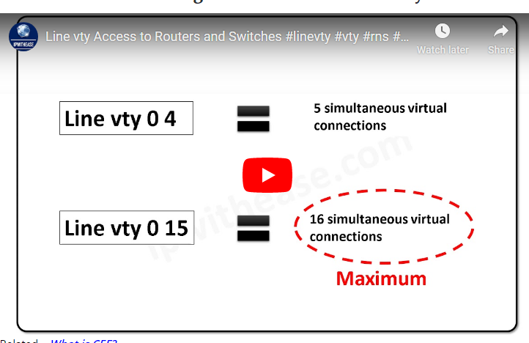
3.4.2 Common security Attacks and counter measures:
A network attack is an attempt to gain unauthorized access to an organization's network, with the objective of stealing data or perform other malicious activity.
a. MAC address Attacks
A media access control attack or MAC flooding is a technique employed to negotiate the
security of network switches. The attack works by forcing legitimate MAC table contents out of
the switch and forcing a unicast flooding behavior potentially sending sensitive information to
portions of the network where it is not normally intended to go.
b. VLAN Hopping
VLAN hopping is a computer security exploit, a method of attacking networked resources on a
virtual LAN (VLAN). The basic concept behind all VLAN hopping attacks is for an attacking
host on a VLAN to gain access to traffic on other VLANs that would normally not be accessible.
c. ARP Attacks
ARP spoofing is a type of attack in which a malicious actor sends falsified ARP (Address
Resolution Protocol) messages over a local area network. This results in the linking of an
attacker's MAC address with the IP address of a legitimate computer or server on the network.
d. DHCP attacks
In DHCP spoofing attacks, the attacker places a rogue DHCP server on the network. As clients
are turned on and request an address, the server with the fastest response is used. If the device
receives a response from the rogue server first, the rogue server can assign any address as well as
control which device it uses as a gateway. A well-designed attack can funnel traffic from local
hosts to a rogue server that logs all traffic and then forwards the traffic out to the “correct”
gateway; to the device, this action would be almost transparent. Thus, the attacker can steal
information almost invisibly.
e. Spoofing Attacks
A spoofing attack is a situation in which a person or program successfully masquerades as
another by falsifying data, to gain an illegitimate advantage.
f. General Attacks
Access Attack
Password Attacks
Port Redirection
Man-in-the-Middle Attacks
Reconnaissance Attacks
Packet Sniffers
Ping Sweeps
Etc...
g. Port security
Configuring Port Security: It involves limiting the NO. of MACs allowed through a port and can
also specify what is the MAC/MACs are., the switch port have to be in access mode, when a
violation occurs one of 3 actions is taken based on your configuration (shutdown, protect and
restrict). the default action is to shutdown the port and a log message will appear, protect means
ignore the violated MAC but there is no way to tell us that a violation had occurred, restrict is the
same as protect but it adds a counter to the violation counter and a log message will appear also.
if a port is shutdown due to violation it have to be manually re opened using the shutdown and
no shutdown commands in the same sequence or using the (config)#errdisable recovery cause
security-violation then to set the recover interval (config)#errdisable recovery interval {time in
sec} and to verify the error disable recovery state #sh errdisable recovery
LU4: VLAN
VLAN Overview
The solution for the community college is to use a networking technology called a virtual LAN (VLAN).A VLAN allows a network administrator to create groups of logically networked devices that act as if they are on their own independent network, even if they share a common infrastructure with other VLANs.Using VLANs, you can logically segment switched networks based on functions, departments, or project teams.A VLAN is a logically separate IP subnetwork.In the figure, one VLAN is created for students and another for faculty.These VLANs allow the network administrator to implement access and security policies to particular groups of users.For example, the faculty, but not the students, can be allowed access to e-learning management servers for developing online course materials.Use graphicUse graphic
Review on broadcast and collusion
Broadcast Domain: No matter how many hosts or devices are connected together, if they are connected with a repeater, hub, switch or bridge, all these devices are in ONE Broadcast domain (assuming a single VLAN). A Router is used to separate Broadcast-Domains (we could also call them Subnets - or call them VLANs). So, if a router stands between all these devices, we have TWO broadcast domains.
Collision Domain: Each connection from a single PC to a Layer 2 switch is ONE Collision domain. For example, if 5 PCs are connected with separate cables to a switch, we have 5 Collision domains. If this switch is connected to another switch or a router, we have one collision domain more. If 5 Devices are connected to a Hub, this is ONE Collision Domain. Each device that is connected to a Layer 1 device (repeater, hub) will reside in ONE single collision domain.

Types of VLANs
In modern networks, there are a number of difwferent types of VLANs. Some of them can beexplained and classiﬁed based on their trafﬁc classes. The other VLAN types could be de-ﬁned by the particular function that they serve.

Data VLAN
A data VLAN could be usedand conﬁgured to bear with the trafﬁc gener-ated by a user. It would not include a VLANcarrying voice or management trafﬁc. It iscommon practice to distinguish voice trafﬁcand management trafﬁc from data trafﬁc. It issometimes referred to as a user VLAN. TheseVLANs are developed to separate the network into groups of users or groups of devices.
Default VLAN
When the default conﬁguration is loaded at the initial boot up, all the ports of switch become a part of the default VLAN These switch ports that are now part of de-fault VLAN, in fact they are part of the same broadcast domain. It means any device connected to any switch port is allowed to communicate with other devices on other switch ports. VLAN 1 is considered as default VLAN for Cisco switches
Voice VLANs
To support Voice over IP(VoIP), a different VLAN is required which can be called as a voice VLAN. VoIP traffic needs the followings:
Assured bandwidth to provide acceptable voice quality

Priority of transmission over other types of network traffics

Routing capability around congested areas on the network

Lesser delay (less than 150ms) across the network These requirements need to be achieved to sup-port VoIP. However, the conﬁguration of these requirements is beyond the scope of this paper, but it is useful to brieﬂy discuss on how a voice VLAN works between a switch, a computer, and a Cisco IP phone

Management VLAN
Any VLAN that isconﬁgured to access the management capabil-ities of a switch is considered as managementVLAN which by default is VLAN 1. By as-signing an IP address and subnet mask to the Switch Virtual Interface (SVI), the manage-ment VLAN can be created and managed via HTTP, Telnet, SSH, or SNMP.It is not a good practice to choose VLAN 1as management VLAN (which is by default)because the out-of-the-box conﬁguration of aCisco switch.
Benefits of a VLAN The primary benefits of using VLANs
Security - Groups that have sensitive data are separated from the rest of the network.
Cost reduction - Cost savings result from less need for expensive network upgrades and more efficient use of existing bandwidth and uplinks.
Higher performance - Dividing flat Layer 2 networks into multiple logical workgroups (broadcast domains) reduces unnecessary traffic on the network. Broadcast storm mitigation - Dividing a network into VLANs reduces the number of devices that may participate in a broadcast storm.Improved IT staff efficiency
- VLANs make it easier to manage the network. When you provision a new switch, all the policies and procedures already configured for the particular VLAN are implemented when the ports are assigned. Simpler project or application management
- Having separate functions makes working with a specialized application easier, for example, an e-learning development platform for faculty. Use graphic.

.
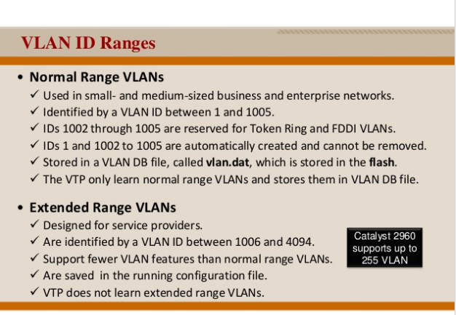
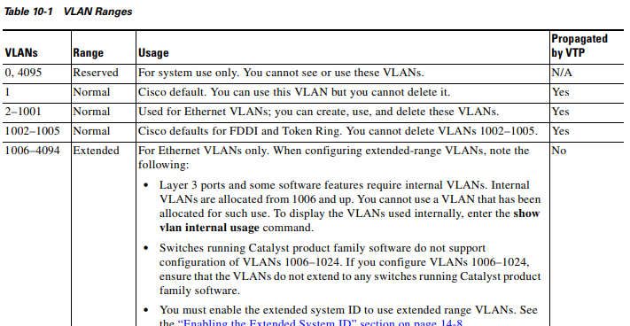

VLAN Membership
There are two types of VLAN memberships:
-Static VLANs
Static VLANs are conﬁgured by network administrator, mainly because of security reason . Since a is assigned manuallyto a VLAN will be always ﬁxed and main-tained. This type of mebership is of course easy to set up and conﬁgure but the manualupdate is required if any changes in the host. Static VLANs are not feasible to be imple-mented for a large network which required fre-quent updates. In this case a dynamic solutionis suggested.
-Dynamic VLANs
VLANs can be assigned automatically using software, based on hard-ware address (MAC), protocols and applications. For instance, assume that a MAC addresses has been listed into centralized VLAN software. If it is attached to an un assigned switch port, the management database of VLAN can look up for the hardware ad-dress and assign and conﬁgure the switch port into the correct VLAN. The difﬁculty of thismethod is to setup the database at the initial level
Controlling broadcast Domains
-Network without VLANs:In the default configuration, when a switch receives a broadcast frame on the ingress ports of the switch it forwards the frame out all ports excluding the port where the broadcast frame was received. Because the whole network is configured in the same subnet and no VLANs are configured therefore all ports are working in the same broadcast domain.
-Network with VLANs:VLANscan be used to limit the reach of broadcast frames ƒA VLAN is a broadcast domain of its own Therefore, a broadcast frame sent by a device in a specific VLANis forwarded within that VLANonly.This help controlling the reach of broadcast frames and their impact in the network ƒUnicast and multicast frames are forwarded within the originating VLANas well.
Controlling broadcast Domains with routers and switches

Controlling Broadcast Domains with Switches and Routers Breaking up a big broadcast domain into several smaller ones reduces broadcast traffic and improves network performance.Breaking up broadcast domains can be per formed either with VLANs (on switches) or with routers.A router is needed any time devices on different Layer 3 networks need to communicate

-Inter VLAN communication known as Inter-VLANrouting is a mechanism in which different Vlans can communicate to each other. Routing between VLANs is based on forwarding network trafﬁcfrom one VLAN to another VLAN using arouter. It allows devices connected to the different VLANs to communicate with each other by using a router. Nodes in a VLAN stay in their own broadcast domain and will be able to communicate freely.

Intra Vlan is a mechanism in which let2 hosts in same VLAN and in different physical L2 switches to communicate to each other.

An access port transports traffic to and from only the specified VLAN allotted to it whereas a trunk port is a port that is assigned to carry traffic for all the
VLANs that are accessible by a specific switch, a process known as
trunking .
2) A trunk port is capable of having more than one VLAN set up on the interface whereas access port is capable of having one VLAN set up on interface
3) in trunk mode, the port is being tagged with VLAN whereas in access mode, the port is been in untagged mode.

Controlling broadcast Domains with VLANs and Layer 3 forwarding

4.2 Describe VLAN trunking
What is a Trunk?
A trunk is a point-to-point link between two network devices that carry more than one VLAN. With VLAN trunking, you can extend your configured VLAN across the entire network. Most Cisco switches support the IEEE 802.1Q used to coordinate trunks on FastEthernet and GigabitEthernet
Benefits of VLAN trunk
- helps to limit configuration errors by keeping VLAN naming consistent across the VTP domain.
-simplifies switch administration by allowing switches to automatically share VLAN configuration information.

VLAN trunk types

- 802.1 Q frame tagging (IEEE)
VLAN Tagging, also known as Frame Tagging, is a method developed by Cisco to help identify packets travelling through trunk links. When an Ethernet frame traverses a trunk link, a special VLAN tag is added to the frame and sent across the trunk link
802.1Q is the IEEE standard for tagging frames on a trunk and supports up to 4096 VLANs. In 802.1Q, the trunking device inserts a 4−byte tag into the original frameand recomputes the frame check sequence (FCS) before the device sends the frame over the trunk link

Native VLANs and 802.1Q Trunking
Tagged frame
Untagged frame
Trunking operation
DTP modes

Computer Network | Dynamic Trunking Protocol (DTP)
Trunk ports are ports that are used to carry the traffic of more than one VLAN.The port which connects two different switches and the switches have more than one VLAN configured then that port should be made trunk. If all the VLANs are allowed then trunk ports will carry traffic of all the VLANs including native VLAN for which the traffic goes untagged otherwise only the allowed VLANs traffic will be carried by the trunk link. The trunk link traffic would be encapsulated or tagged either by ISL or 802.1Q.
By default, all switch ports are access ports therefore to make a port trunk, user should manually make it trunk by using DTP .
Dynamic Trunking Protocol –
Dynamic Trunking Protocol is CISCO proprietary protocol used for negotiating a trunk link between two switches as well as the encapsulation type of either 802.1q or ISL (Generally, 802.1q is used because ISL has more overhead than 802.1q). Of course, It is a layer 2 (data link) protocol and is enabled by default.
Here are the different options available while configuring a switch interface:-
switchport mode access (DTP mode OFF) –
ON (default) modeThis mode puts the switch interface into permanent non trunking mode regardless of whether the neighbouring interface is trunk port or trying to become a trunk port that is why it is known as DTP mode OFF. The port is a dedicated layer 2 access port
Dynamic auto mode
Dynamic desirable mode
Turn off DTP mode

INTER VLAN COMMUNICATION CONFIGURATION

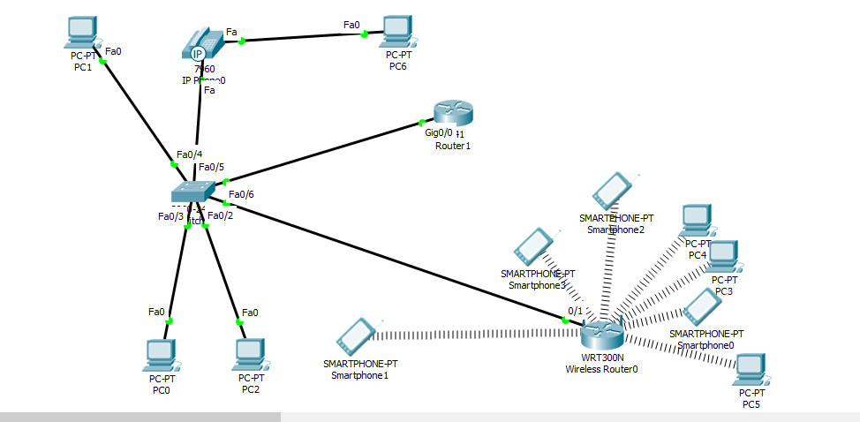
A. SWITCH CONFIGURATION
STEP1:Creationof VLAN
Switch>EN
Switch#CONF T
Switch(config)#VLAN 10
Switch(config-vlan)#NAME ICT
Switch(config-vlan)#VLAN 20
Switch(config-vlan)# NAME ADMNISTRATION
Switch(config-vlan)#VLAN 30
Switch(config-vlan)#NAME STUDENT
Switch(config-vlan)#EXIT
STEP2: PORT ASSIGNMENT
Switch(config)#InterfaceRANGE F0/2-3
Switch(config-if-range)#SWITCHPort MODE ACCess
Switch(config-if-range)#SWItchport ACCess VLAn 10
Switch(config-if-range)#EXIT
Switch(config)#INTERface RANGe F0/4-5
Switch(config-if-range)#SWITCHPort MODE ACCess
Switch(config-if-range)#SWItchport ACCess VLAn 20
Switch(config-if-range)#EXIT
Switch(config)#INTERFace F0/6
Switch(config-if)#SWITCHPort MODE ACCess
Switch(config-if)#SWItchport ACCess VLAn 30
Switch(config-if)#EXIT
Switch(config)#INTERface F0/1
Switch(config-if)#SWITCHPort MODE TRUNk
Switch(config)#INTERface F0/5
Switch(config-if)#SWitchport VOIce VLAN 20
Switch(config-if)#SWitchport access VLAN 20
B.CONFIGURATION OF THE ROUTER
STEP1:SUB INTERFACE CONFIGURATION
For VLAN to be able to communicate ,we create the sub-interface inside the router.
outer>EN
Router#CONF T
Router(config)#INTERface G0/0
Router(config-if)#NO Shutdown
Router(config-if)#NO IP ADdress
Router(config-if)#EXIT
Router(config)#INTERface G0/0.10
Router(config-subif)#IP ADdress 192.168.10.254 255.255.255.0

Router(config-subif)#ENCapsulation Dot1Q 20
Router(config-subif)#IP ADdress 192.168.20.254 255.255.255.0
Router(config-subif)#EXIT
Router(config-subif)#INTERface G0/0.30
Router(config-subif)#ENCapsulation Dot1Q 30
Router(config-subif)#IP ADdress 192.168.30.254 255.255.255.0
Router(config-subif)#EXIT

STEP2: DHCP CONFIGURATION
Router(config)#IP DHcp POol VLAN10
Router(dhcp-config)#NETwork 192.168.10.0 255.255.255.0
Router(dhcp-config)#DEfault-router 192.168.10.254
Router(dhcp-config)#EXIT
Router(config)#IP DHcp POol VLAN20
Router(dhcp-config)#NETwork 192.168.20.0 255.255.255.0
Router(dhcp-config)#DEfault-router 192.168.20.254
Router(dhcp-config)#EXIT
Router(config)#IP DHcp POol VLAN30
Router(dhcp-config)#NETwork 192.168.30.0 255.255.255.0
Router(dhcp-config)#DEfault-router 192.168.30.254
Router(dhcp-config)#DO WR
Then request for DHCP for each computer by clicking on the computer –DESKTOP-IP-DHCP the ip and default gateway is automatically assigned to the computer then you can check the communication between computers indifference VLANs.

VOICE VLAN CONFIGURATION
The voice VLAN is how we can configure a phone to a switch so that it can communicate using the network

LU5:V TP CONFIGURATION
Learning Outcome 5.1 Describe the VTP Concepts
• What is a VTP?
VTP is a Layer 2 messaging protocol that maintains VLAN configuration consistency by managing the addition, deletion, and renaming of VLANs on a network-wide basis. VTP minimizes misconfigurations and configuration inconsistencies that can cause several problems, such as duplicate VLAN names, incorrect VLAN-type specifications, and security violations
Before you create VLANs, you must decide whether to use VTP in your network. Using VTP, you can make configuration changes centrally on one or more switches and have those changes automatically communicated to all the other switches in the network. Without VTP, you cannot send information about VLANs to other switches.
VTP is designed to work in an environment where updates are made on a single switch and are sent through VTP to other switches in the domain. It does not work well in a situation where multiple updates to the VLAN database occur simultaneously on switches in the same domain, which would result in an inconsistency in the VLAN database

• VTP BENEFITS
Advantages:
- Reduce mis-configuration.
- Centralize VLAN management, We can add, edit, delete vlan on VTP server then it will distributed to other switch in the same VTPdomain.
- Reduce time to configure the same VLANs everywhere in the network.
• VTP components:
- VTP Domain : A VTP domain (also called a VLAN management domain) consists of one switch or several interconnected switches under the same administrative responsibility sharing the same VTP domain name. A switch can be in only one VTP domain. You make global VLAN configuration changes for the domain
By default, the switch is in the VTP no-management-domain state until it receives an advertisement for a domain over a trunk link (a link that carries the traffic of multiple VLANs) or until you configure a domain name. Until the management domain name is specified or learned, you cannot create or modify VLANs on a VTP server, and VLAN information is not propagated over the network.
Note that the client and server switches must have same vtp domain

VTP Advertisement: VTP Advertisements
Each switch in the VTP domain sends periodic global configuration advertisements from each trunk port to a reserved multicast address. Neighboring switches receive these advertisements and update their VTP and VLAN configurations as necessary.
- VTP Modes: VTP Modes are
- VTP Server Mode :
- VTP Client Mode :
- VTP Transparent Mode:
VTP Mode | Description
VTP server | In VTP server mode, you can create, modify, and delete VLANs, and specify other configuration parameters (such as the VTP version) for the entire VTP domain. VTP servers advertise their VLAN configurations to other switches in the same VTP domain and synchronize their VLAN configurations with other switches based on advertisements received over trunk links.  VTP server is the default mode.  Note In VTP server mode, VLAN configurations are saved in NVRAM. If the switch detects a failure while writing a configuration to NVRAM, VTP mode automatically changes from server mode to client mode. If this happens, the switch cannot be returned to VTP server mode until the NVRAM is functioning.
VTP client | A VTP client behaves like a VTP server and transmits and receives VTP updates on its trunks, but you cannot create, change, or delete VLANs on a VTP client. VLANs are configured on another switch in the domain that is in server mode.  In VTP versions 1 and 2, in VTP client mode, VLAN configurations are not saved in NVRAM. In VTP version 3, VLAN configurations are saved in NVRAM in client mode.
VTP transparent | VTP transparent switches do not participate in VTP. A VTP transparent switch does not advertise its VLAN configuration and does not synchronize its VLAN configuration based on received advertisements. However, in VTP version 2 or version 3, transparent switches do forward VTP advertisements that they receive from other switches through their trunk interfaces. You can create, modify, and delete VLANs on a switch in VTP transparent mode.  In VTP versions 1 and 2, the switch must be in VTP transparent mode when you create extended-range VLANs. VTP version 3 also supports creating extended-range VLANs in client or server mode  When the switch is in VTP transparent mode, the VTP and VLAN configurations are saved in NVRAM, but they are not advertised to other switches. In this mode, VTP mode and domain name are saved in the switch running configuration, and you can save this information in the switch startup configuration file by using the copy running-config startup-config privileged EXEC command.
VTP off | A switch in VTP off mode functions in the same manner as a VTP transparent switch, except that it does not forward VTP advertisements on trunks.

- VTP Pruning
VTP pruning increases network available bandwidth by restricting flooded traffic to those trunk links that the traffic must use to reach the destination devices. Without VTP pruning, a switch floods broadcast, multicast, and unknown unicast traffic across all trunk links within a VTP domain even though receiving switches might discard them. VTP pruning is disabled by default.

VTP pruning blocks unneeded flooded traffic to VLANs on trunk ports that are included in the pruning-eligible list. Only VLANs included in the pruning-eligible list can be pruned. By default, VLANs 2 through 1001 are pruning eligible switch trunk ports. If the VLANs are configured as pruning-ineligible, the flooding continues. VTP pruning is supported in all VTP versions

Learning Outcome 5.2.Describe VTP Operation

Default VTP configuration
- VTP version :
There are three version of VTP so far. VTP Version 2 (V2) is not much different than VTP Version 1 (V1). The major difference is that VTP V2 introduces the support for Token Ring VLANs. If you are using Token Ring VLANs, you need to enable VTP V2. Otherwise, there is no reason to use VTP V2. VTP version 3 differs from earlier VTP versions in that it does not directly handle VLANs. VTP version 3 is a protocol that is only responsible for distributing a list of opaque databases over an administrative domain. When enabled, VTP version 3 provides the following enhancements to previous VTP versions:
- Support for extended VLANs.
- Support for the creation and advertising of private VLANs.
- Improved server authentication.
- Protection from the "wrong" database accidentally being inserted into a VTP domain.
- Interaction with VTP version 1 and VTP version 2.
- Provides the ability to be configured on a per-port basis.
- Provides the ability to propagate the VLAN database another databases.

- Configuration revisions: The VTP revision number concept allows switches to know when VLAN database changes have occurred. Upon receiving a VTP update, if the revision number in a received VTP update is larger than a switch's current revision number, it believes that there is a new version of the VLAN database. The new switch's revision number is larger than that of the existing switches.
- VTP Domains name• VTP allows you to separate your network into smaller management domains to help reduce VLAN management. • A VTP domain consists of one switch or several interconnected switches sharing the same VTP domain name. • An additional benefit of configuring VTP domains is that it limits the extent to which configuration changes are propagated in the network if an error occurs. • A switch can be a member of only one VTP domain at a time. • Until the VTP domain name is specified you cannot create or modify VLANs on a VTP server, and VLAN information is not propagated over the network
VTP Domain Name Propagation • For a VTP server or client switch to participate in a VTP-enabled network, it must be a part of the same domain. • When switches are in different VTP domains, they do not exchange VTP messages. • Domain name propagation uses three VTP components: servers, clients, and advertisements. • The network in the figure shows three switches, S1, S2, and S3, in their default VTP configuration. • They are configured as VTP servers. • VTP domain names have not been configured. • The network manager
configures the VTP domain name as cisco1 on the VTP server switch S1. • The VTP server sends out a VTP advertisement with the new domain name embedded inside. • The S2 and S3 VTP server switches update their VTP configuration to the new domain name. • Cisco recommends that access to the domain name configuration functions be protected by a password.
VTP Frame Structure • VTP advertisements (or messages) distribute VTP domain name and VLAN configuration changes to VTP-enabled switches. • VTP Frame Encapsulation • A VTP frame consists of a header field and a message field. • The VTP information is inserted into the data field of an Ethernet frame. • The Ethernet frame is then encapsulated as a 802.1Q trunk frame (or ISL frame). • Each switch in the domain sends periodic advertisements out each trunk port to a reserved multicast address. • These advertisements are received by neighboring switches, which update their VTP and VLAN configurations as necessary
- VTP Revision Number • The configuration revision number determines whether the configuration information received from another VTP-enabled switch is more recent than the version stored on the switch. • The configuration revision number is a 32-bit number. • The default revision number for a switch is zero. • Each time a VLAN is added or removed, the configuration revision number is incremented. • Each VTP device tracks the VTP configuration revision number that is assigned to it. • Note: A VTP domain name change does not increment the revision number. • Instead, it resets the revision number to zero.
Troubleshooting VTP: Incompatible VTP Versions • VTP versions 1 and 2 are incompatible with each other. • Modern Cisco Catalyst switches, such as the 2960, are configured to use VTP version 1 by default. • However, older switches may only support VTP version 1. • Switches that only support version 1 cannot participate in the VTP domain along with version 2 switches. • If your network contains switches that support only version 1, you need to manually configure the version 2 switches to operate in version 1 mode.
Troubleshooting VTP: VTP Password Issues • When using a VTP password to control participation in the VTP domain, ensure that the password is set correctly on all switches in the VTP domain. • Forgetting to set a VTP password is a very common problem. • If a password is used, it must be configured on each switch in the domain. • By default, a Cisco switch does not use a VTP password. • The switch does not automatically set the password parameter, unlike other parameters that are set automatically when a VTP advertisement is received.
Troubleshooting VTP: Incorrect VTP Domain Name • The VTP domain name is a key parameter that is set on a switch. • An improperly configured VTP domain affects VLAN synchronization between switches. • As you learned earlier, if a switch receives the wrong VTP advertisement, the switch discards the message. • Solution • To avoid incorrectly configuring a VTP domain name, only set the VTP domain name on one VTP server switch. • All other switches in the same VTP domain will accept and automatically configure their VTP domain name when they receive the first VTP summary advertisement.
Troubleshooting VTP: Switches Set to VTP Client Mode • It is possible to change the operating mode of all switches to VTP client. • By doing so, you lose all ability to create, delete, and manage VLANs within your network environment. • Solution • To avoid losing all VLAN configurations in a VTP domain by accidentally reconfiguring the only VTP server in the domain as a VTP client, you can configure a second switch in the same domain as a VTP server. • It is not uncommon for small networks that use VTP to have all the switches in VTP server mode.
Troubleshooting VTP: Incorrect Revision Number • The topology in the figure is configured with VTP. There is one VTP server switch, S1, and two VTP client switches, S2 and S3. • S4, which has been previously configured as a VTP client, is added to the network. • The revision number of the switch S4 is 35, which is higher than the revision number of 17 in the existing network. • S4 comes preconfigured with two VLANs, 30 and 40, that are not configured in the existing network. • The existing network has VLANs 10 and 20. • When switch S4 is connected to switch S3, VTP summary advertisements announce the arrival of a VTP-enabled switch with the highest revision number in the network. • The figure shows how switch S3, switch S1, and finally switch S2 all reconfigure themselves to the configuration found in switch S4. • As each switch reconfigures itself with VLANs that are not supported in the network, the ports no longer forward traffic from the computers because they are configured with VLANs that no longer exist on the newly reconfigured switches.
Troubleshooting VTP: Incorrect Revision Number • Solution • The solution to the problem is to reset each switch back to an earlier configuration and then reconfigure the correct VLANs, 10 and 20, on switch S1. • To prevent this problem in the first place, reset the configuration revision number on previously configured switches being added to a VTP-enabled network. • The figure shows the commands needed to reset switch S4 back to the default revision number. • POP QUIZ: • How about just power cycle the switch 4 and rest the revision number before plug it into the network?
Managing VLANs on a VTP Server • When a new VLAN, for example, VLAN 10, is added to the network, the network manager adds the VLAN to the VTP server, switch S1 in the figure. • As you know, VTP takes care of propagating the VLAN configuration details to the rest of the network. • It does not have any effect on which ports are configured in VLAN 10 on switches S1, S2, and S3. • The figure displays the commands used to configure VLAN 10 and the port F0/11 on switch S1. • After you have configured the new VLAN on switch S1 and configured the ports on switches S1, S2, and S3 to support the new VLAN, confirm that VTP updated the VLAN database on switches S2 and S3. • The output of the command is used to verify the configuration on switch S2. • The output confirms that the new VLAN has been added to F0/1 on switch S2. The highlighted area shows that VLAN 10 is now active in the VTP management domain.
Summary • VTP is a Cisco proprietary protocol used to exchange VLAN information across trunk links. • A switch can be in one of 3 VTP operating modes
VTP configuration
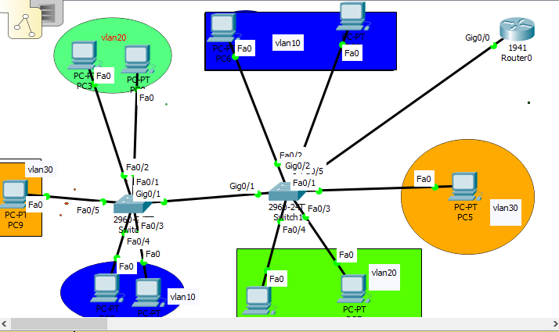

A.Configure server switch
STEP1:CONFIGURE VTP
Switch(config)#vtp mode server
.Switch(config)#vtp domain GIHEKE
STEP2:Configure VLANS IN SERVER SWITCH
Switch(config)#VLAN 10
Switch(config-vlan)#NAME ICT
Switch(config-vlan)#EXIT
Switch(config)#VLAN 20
Switch(config-vlan)#NAME ADMIN
Switch(config-vlan)#VLAN 30
Switch(config-vlan)#NAME STUDENT
Switch(config-vlan)#EXIT
VTP PASSWORD
Switch(config)#VTP PASSword NETWORKING
Setting device VLAN database password to NETWORKING
ASSIGN PORT
Switch(config)#INTERface G0/1
Switch(config-if)#SWItchport MODE TRUNK

Switch(config-if)#EXIT
Switch(config)#INTERface range f0/3-4
Switch(config-if-range)#sw
Switch(config-if-range)#switchport mo
Switch(config-if-range)#switchport mode acc
Switch(config-if-range)#switchport mode access
Switch(config-if-range)#EXIT
Switch(config)#INTERface f0/2
Switch(config-if)#switchport mode access
Switch(config-if)#switchport access vlan 10
Switch(config-if)#exit
Switch(config)#INTERface f0/5
Switch(config-if)#switchport mode access
Switch(config-if)#switchport access vlan 10
Switch(config-if)#exit
Switch(config)#INTERface f0/1
Switch(config-if)#switchport mode access
Switch(config-if)#switchport access vlan 30
Switch(config-if)#INTERface raf0/5
Switch(config-if)#INTERface range f0/3-4
Switch(config-if-range)#switchport mode access
Switch(config-if-range)#switchport access vlan 20
Switch(config-if-range)#exit
Switch(config)#interface g0/2
Switch(config-if)#switchport mode trunk
Switch(config-if)#exit

B. CONFIGURE CLIENT
When configuring the client switch , the domain name and the password to configure must be the same as that configured in the server switch
Switch>EN
Switch#CONF T
Switch(config)#VTP Mode CLIENT
Setting device to VTP CLIENT mode.
Switch(config)#VTP Domain GIHEKE
Switch(config)#VTP PAssword NETWORKING
To view the vtp status use show vtp status command
Switch(config)#DO SH VTP ST
Switch(config)#EXIT
To view the vlans information use show VLAN command
NOTE: you must not create the VLANS in the client switch because vtp will advertise the vlans from the server switch.
Port assignment in client switch
Switch(config)#inter
Switch(config)#interface ran
Switch(config)#interface range f0/1-2
Switch(config-if-range)#switchport mode access
Switch(config-if-range)#switchport access vlan 20
Switch(config-if-range)#exit
Switch(config)#interface range f0/3-4
Switch(config-if-range)#switchport mode access
Switch(config-if-range)#switchport access vlan 10
Switch(config-if-range)#interface f0/5
Switch(config-if)#switchport mode access
Switch(config-if)#switchport access vlan 30
Switch(config-if)#exit
Switch(config)#do wr

C. DHCP CONFIGURATION
STEP1:ENCAPSLATION
IEEE 802.1Q encapsulation is configurable on Ethernet and EtherChannel interfaces. IEEE 802.1Q is a standard protocol for interconnecting multiple switches and routers and for defining VLAN topologies. Use the encapsulation dot1q command in sub-interface range configuration mode to apply a VLAN ID to the subinterface
Router>en
Router#conf t
Enter configuration commands, one per line. End with CNTL/Z.
Router(config)#inter
Router(config)#interface g0/0
Router(config-if)#no sh
Router(config-if)#no shutdown
Router(config-if)#no ip address
Router(config-if)#exit.
Router(config-subif)#interface g0/0.10
Router(config-subif)#enc
Router(config-subif)#encapsulation do
Router(config-subif)#encapsulation dot1Q 10
Router(config-subif)#ip ad
Router(config-subif)#ip address 192.168.10.100 255.255.255.0
Router(config-subif)#interface g0/0.20
Router(config-subif)#encapsulation dot1Q 20
Router(config-subif)#ip address 192.168.20.100 255.255.255.0
Router(config-subif)#exit
Router(config)#interface g0/0.30
Router(config-subif)#encapsulation dot1Q 30
Router(config-subif)#ip address 192.168.30.100 255.255.255.0
Router(config-subif)#do wr
Router(config-subif)#exit
Router(config)#ip dh
Router(config)#ip dhcp pool vlan10
Router(dhcp-config)#net
Router(dhcp-config)#network 192.168.10.0 255.255.255.0
Router(dhcp-config)#de
Router(dhcp-config)#default-router 192.168.10.100
Router(dhcp-config)#exit
Router(config)#ip dhcp pool vlan20
Router(dhcp-config)#network 192.168.20.0 255.255.255.0
Router(dhcp-config)#default-router 192.168.20.100
Router(dhcp-config)#exit
Router(config)#ip dhcp pool vlan30
Router(dhcp-config)#network 192.168.30.0 255.255.255.0
Router(dhcp-config)#default-router 192.168.30.100
Router(dhcp-config)#exit

LU6: Perform STP configurations
Learning Outcome 6.1 Describe the STP Concepts
• Introduction to STP

Switching loops?
Switches flood traffic out all ports when the traffic is sent to a destination that is not yet known
Broadcast and multicast traffic is forwarded out every port, except the port on which the traffic arrived
Avoiding Switching Loops
The Spanning-Tree Protocol is used in switched networks to create a loop free logical topologyfrom a physical topology that has loops.

IEEE 802.1D Spanning-Tree Protocol Used by Ethernet bridges and switches to construct a loop free shortest path network using the spanning-tree algorithm
ƒShortest path is based on cumulative link costs Link costs are based on the speedof the link
The Spanning-Tree Protocol establishes a root node, called the root bridge STP constructs a topology that has one path for reaching every network node The resulting tree originates from the root bridge Redundant links that are not part of the shortest path tree are blocked. Data frames received on blocked links are dropped.
Because certain paths are blocked, a loop free topology is possible
.
• Redundancy
Redundancy means to be overloaded or exceeding what is usual and natural
- Examine a redundant design
In bigger networks, having a redundant design is crucial. Redundant network designs allows service continuity in case of link failure. However, the most common you will encounter will be loops. Loops are created when multiple paths exist between two network devices. IP packets have a time to live (T TL), but Ethernet frames don’t. The result is that Ethernet frames willendlessly bounce between two switches if a loop is present in your network. The same goes for broadcast messages, but they’re effect is bigger, meaning that you have big chances to end with a Broadcast Storm

- Issues with redundancy
1. Broadcast Storms
A broadcast storm occurs when there are so many broadcast frames caught in a Layer 2 loop that all available bandwidth is consumed. Consequently, no bandwidth is available for legitimate traffic and the network becomes unavailable for data communication. This is an effective denial of service. A broadcast storm is inevitable on a looped network. As more devices send broadcasts over the network, more traffic is caught within the loop, consuming resources. This eventually creates a broadcast storm that causes the network to fail. There are other consequences of broadcast storms. Because broadcast traffic is forwarded out every port on a switch, all connected devices have to process all broadcast traffic that is being flooded endlessly around the looped network. This can cause the end device to malfunction because of the high processing requirements for sustaining such a high traffic load on the NIC.
The following steps demonstrate the broadcast storm issue. Figure 2-3 shows the final result during Step 6.
1. PC1 sends a broadcast frame out onto the looped network.
2. The broadcast frame loops between all the interconnected switches on the network
. 3. PC4 also sends a broadcast frame out on to the looped network.
4. The PC4 broadcast frame also gets caught in the loop between all the interconnected switches, just like the PC1 broadcast frame.
5. As more devices send broadcasts over the network, more traffic is caught within the loop, consuming resources. This eventually creates a broadcast storm that causes the network to fail.
6. When the network is fully saturated with broadcast traffic that is looping between the switches, new traffic is discarded by the switch because it is unable to process it. In Figure below, S2 is now discarding additional frames.
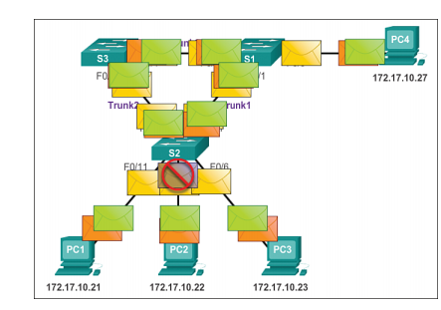

A broadcast storm because Spanning Tree Protocol is not enabled

2. Duplicate Unicast Frames
Broadcast frames are not the only type of frames that are affected by loops. Unicast frames sent onto a looped network can result in duplicate frames arriving at the destination device. The following steps demonstrate the duplicate unicast frames issue. Figure 2-4 shows a snapshot during Step 5 and Step 6.
1. PC1 sends a unicast frame destined for PC4.
2. S2 does not have an
entry for PC4 in its MAC table, so it floods the unicast frame out all switch ports in an attempt to find PC4.
3. The frame arrives at switches S1 and S3.
4. S1 does have a MAC address entry for PC4, so it forwards the frame out to PC4.
5. S3 also has an entry in its MAC address table for PC4, so it forwards the unicast frame out Trunk3 to S1.
6. S1 receives the duplicate frame and forwards the frame out to PC4.
7. PC4 has now received the same frame twice.
To prevent these issues from occurring in a redundant network, some type of spanning tree must be enabled on the switches. Spanning tree is enabled, by default, on Cisco switches to prevent Layer 2 loops from occurring.
- Real word redundancy issues
• Spanning Tree Algorithm
STP executes an algorithm called Spanning Tree Algorithm (STA).
  - STA chooses a reference point, called a root bridge.
  - Then determines the available paths to that reference point.
  - If more than two paths exists, STA picks the best path and blocks the rest

• Bridge ID
- STP calculations make extensive use of two key concepts in creating a loop-free topology:
  - Bridge ID
  - Path Cost
Bridge ID:
- Bridge ID (BID) is used to identify each bridge/switch.
- The BID is used in determining the center of the network, in respect to STP, known as the root bridge.
- Bridge ID Consists of two components:
- A 2-byte Bridge Priority: Cisco switch defaults to 32,768 .Usually expressed in decimal format
- A 6-byte MAC address .Usually expressed in hexadecimal format.
Each switch has a unique BID
BID is used to elect a root bridge (coming). Lowest Bridge ID is the root.
If all devices have the same priority, the bridge with the lowest MAC address becomes the root bridge
Path Cost
Bridges use the concept of cost to evaluate how close they are to other bridges. Used to create the loop-free topology

• STP BDU
The Spanning-Tree Protocol requires network devices to exchange messages to help form a loop-free logical topology
These messages are called Bridge Protocol Data Units (BPDUs) Links that will cause a loop are put into a blocking state BPDUs continue to be received on blocked ports (ensures that if an active path or device fails, a new spanning tree can be calculated)
BPDUs manages the port states or mode
BPDUs help switches do the following:
- Select a single switch that will act as the root of the spanning tree
- Calculate the shortest path from itself to the root switch
- Designate one of the switches as the closest one to the root, for each LAN segment. This bridge is called the “designated switch” The designated switch handles all communication from that LAN towards the root bridge.
- Choose one of its ports as a root port(if it is a non-root switch) This is the interface that gives the best path to root switch.
- Select ports that are part of the spanning tree, called designated ports ,Non-designated ports are blocked
Information in BPDU
• Port roles
The role is now a variable assigned to a given port.
Port role are :
1. Root port
2 .Designated port
3. Blocking port role
4 .Alternate port roles
The root port and designated port roles remain, while the blocking port role is split into the backup and alternate port roles. In order to simplify matters, the thing to remember about a BPDU is there is always a method to compare any two of them and decide whether one is more useful than the other
- Root Port Roles
The port that receives the best BPDU on a bridge is the root port. This is the port that is the closest to the root bridge in terms of path cost. The STA elects a single root bridge in the whole bridged network (per-VLAN). The root bridge sends BPDUs that are more useful than the ones any other bridge sends. The root bridge is the only bridge in the network that does not have a root port. All other bridges receive BPDUs on at least one port
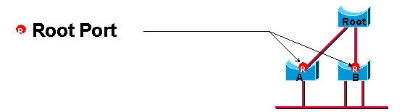
- . Designated port
A port is designated if it can send the best BPDU on the segment to which it is connected.. On a given segment, there can only be one path toward the root bridge. If there are two, there is a bridging loop in the network. All bridges connected to a given segment listen to the BPDUs of each and agree on the bridge that sends the best BPDU as the designated bridge for the segment. The port on that bridge that corresponds is the designated port for that segment
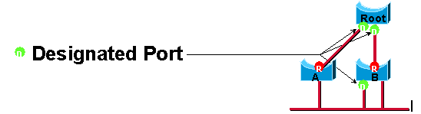
- Alternate Port Roles
An alternate port receives more useful BPDUs from another bridge and is a port blocked. An alternate port provides an alternate path to the root bridge and therefore can replace the root port if it fails.
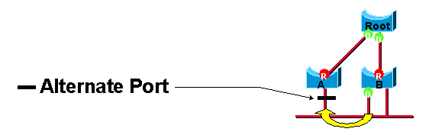
- Backup Port Roles

Backup port provides redundant connectivity to the same segment and cannot guarantee an alternate connectivity to the root bridge. Therefore, it is excluded from the uplink group.
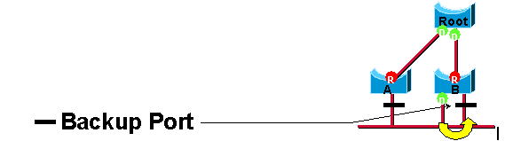

• STP port states and BPDU Timers

- Blocking State :Ports can only receive BPDUs Data frames are discarded and no addresses can be learned It may take up to 20 seconds to change from this state

- Listening State: Switches determine if there are any other paths to the root bridge .The path that is not the least cost path to the root bridge goes back to the blocked state BPDUs are still processed. The listening period is called the forward delay and lasts for 15 seconds.
- Learning State: user data is not forwarded, but MAC addresses are learned from any traffic that is seen The learning state lasts for 15 seconds and is also called the forward delay BPDUs are still processed
- Forwarding state :user data is forwarded and MAC addresses continue to be learned BPDUs are still processed .
- Disabled State (Fifth State) can occur when an administrator shuts down the port or the port fails.
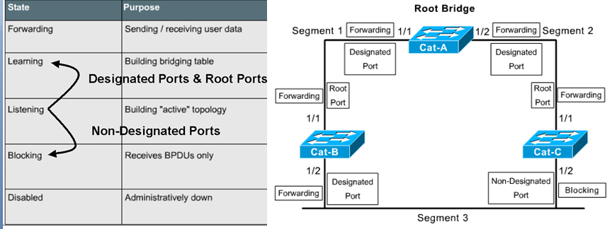

Learning Outcome 6.2. Converge STP

- Electing roots bridge
A Root Bridge is a reference point for all switches in a spanning-tree topology. Across all connected switches a process of election occurs.

Conditions to elect bridge root

- switch with the Lowest Bridge ID is elected as the Root Bridge.
- Switch with lowest MAC address is elected

- Elect roots port
Once a Root Bridge is elected all non-root Bridges elect a Root Port. This is a port that has the lowest cumulative path cost towards the Root Bridge

- Electing designated ports and non designated ports

Once a Root Bridge is elected all non-root Bridges elect a Root Port. This is a port that has the lowest cumulative path cost towards the Root Bridge Lists the Default Port Costs according to the IEEE 802.1D
Link Bandwidth | STP Cost
4 Mbps | 250
10 Mbps | 100
100 Mbps | 19
1 Gbps | 4
10 Gbps | 2

- Select one Designated Port on each segment
The final step is to select one Designated Port on each segment. The Port that advertises the lowest Root Path Cost onto the segment is elected as Designated Port. Both Switches advertise 4 as the Root Path Cost.
NOTE: Whenever selecting Root Ports or Designated Ports if two or more ports report the same Root Path Cost then the following tie breaker mechanism occurs
- Lowest Sender Bridge ID
- Lowest Sender Port Priority
- Lowest Sender Port Number

- STP topology change
The network topology can happen in a network due to different reasons like a link failure, a Switch (Bridge) failure, or a port transitioning to forwarding state.

The topology change must be notified to all Switches (Bridges) in the network and the process involves two steps:
• The Switch (Bridge) notifies the topology change to Root Bridge
• The Root Switch (Bridge) bridge broadcasts the topology change information into the whole network.
When a Switch (Bridge) discovers topology change, it generates a TCN (Topology Change Notification) BPDU (Bridge Protocol Data Unit) and sends the TCN BPDU on its root port. The upstream Switch (Bridge) responds back the sender with TCA (Topology Change Acknowledgment) BPDU (Bridge Protocol Data Unit) and TCA (Topology Change Acknowledgment) BPDU (Bridge Protocol Data Unit)
When the Root Switch (Root Bridge) is aware that there is a topology change in the network, it starts to send out its Configuration BPDUs with the topology change (TC) bit set. Configuration BPDUs are received by every Switch (Bridge) in the network and all bridges become aware of the network topology change.
Switches (Bridges) keep its MAC address table entries for 300 seconds (5 minutes, known as aging time), by default. When a network topology change happens, the Switch (Bridge) temporarily lowers the aging time to the same as the forward delay time (15 seconds) to relearn the MAC address changes happened because of topology change.
This is important because normally only after five minutes an entry is aged out from the MAC address table of the switch and the network devices could be unreachable for up to 5 minutes. This is known as a black hole because frames can be forwarded to a device, which is no longer available.

STP CONFIGURATION

Know the spanning tree to know which switch is going to be a root bridge or
JKK.Configure vlans in the root bridge
Configure vtpin each switch(aluays the bridge switch must be server
Configure the dhcp in the router
Configure R STP
STEPS TO CONFIGURE STP
A. CONFIGURE THE SWITCH TO BE ROOT BRIDGE

Step 1:VLAN CONFIGURATION in the root bridge

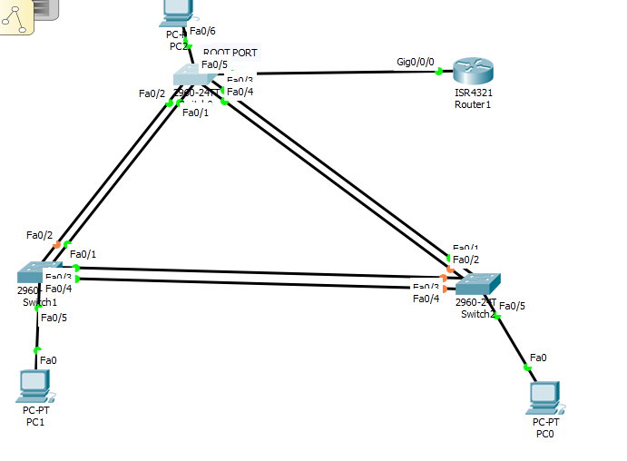
Switch>EN
Switch#CONF T
Enter configuration commands, one per line. End with CNTL/Z.
Switch(config)#VLAN 10
Switch(config-vlan)#NAME ICT
Switch(config-vlan)#VLAN 20
Switch(config-vlan)#NAME ADMINISTRATION
Switch(config-vlan)#VLAN 30
Switch(config-vlan)#NAME STUDENT
Switch(config-vlan)#EXIT
Step2: VTP CONFIGURATION
Switch(config)#VTP MODE SERVER
Device mode already VTP SERVER.
Switch(config)#vtp domain GIHEKE
Switch(config)#VTP password L4
Step3: Port Assignment
Switch(config)#INTerface RANGE F0/1-5
Switch(config-if-range)#SWitchport MOde TRUNK
Switch(config-if)#exit
Switch(config)#INTERface F0/6
Switch(config-if)#Switchport Mode ACcess
Switch(config-if)#Switchport ACcess vlan 30
Switch(config-if)#exit
Configure STP in root bridge
Switch(config)#SPanning-tree mode Rapid-PVST

Electing Primary and Secondary Root Bridges for Each VLAN

A secondary root bridge is a switch that may become the root bridge for a VLAN if the primary root bridge fails. Assuming that the other bridges in the VLAN retain their default STP priority, this switch becomes the root bridge if the primary root bridge fails.
Switch(config)#SPanning-tree Vlan 10 ROot PRIMARY
Switch(config)#SPanning-tree Vlan 20 ROot SECondary
Switch(config)#EXIT
Note: it is not necessary that Primary and Secondary Root Bridges for Each VLAN must be configured on Root Bridges .you can choose primary and second root bridge for a certain vlan on your choice

Configuring PortFast
Switch(config)# interface FastEthernet 0/6
Switch(config-if)# spanning-tree portfast

Note:Because the purpose of PortFast is to minimize the time that access ports must wait for spanning tree to converge, it should be used only on access ports. If you enable PortFast on a port connecting to another switch, you risk creating a spanning-tree loop.

Configuring and Verifying BPDU Guard
Switch(config)#interface F0/6
Switch(config-if)#spanning-tree BPduguard enable
Switch(config-if)#exit

- MULTILAYER SWITCH CONFIGURATION

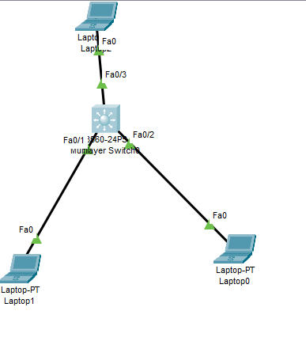
Switch>en
Switch#conf t
Switch(config)#vlan 10
Switch(config-vlan)#Name ICT
Switch(config-vlan)#VLAN 20
Switch(config-vlan)#NAME HR
Switch(config-vlan)#EXIT
Switch(config)#INTERFACEvlan 10
Switch(config)#interface vlan 10

Switch(config-if)#ip address 192.168.10.1 255.255.255.0
Switch(config-if)#no sh
Switch(config-if)#interface vlan 20
Switch(config-if)#
Switch(config-if)#no sh
Switch(config-if)#ip address 192.168.20.1 255.255.255.0
Switch(config-if)#ip dhcp pool vlan10
Switch(dhcp-config)#network 192.168.10.0 255.255.255.0
Switch(dhcp-config)#default-router 192.168.10.1
Switch(dhcp-config)#exit
Switch(config)#ip dhcp pool vlan20
Switch(dhcp-config)#network 192.168.20.0 255.255.255.0
Switch(dhcp-config)#default-router 192.168.10.1
Switch(dhcp-config)#exit
Switch(config)#ip routing
Switch(config)#interface range f0/1-2
Switch(config-if-range)#switchport mode access
Switch(config-if-range)#switchport access vlan 10
Switch(config-if-range)#exit
Switch(config)#interface f0/3
Switch(config-if)#switchport mode access
Switch(config-if)#switchport access vlan 20
Switch(config-if)#do wr

LU7: Implement Inter-VLAN routing
Learning Outcome 7.1 Introduce inter VLAN routing

Introduction to inter-vlan routing.
When we learnt about VLANs, we said that each VLAN is usually on its own subnet, switches mainly operate at layer 2 of the OSI model and therefore they do not examine the logical addresses. Therefore, user nodes located on different VLANs cannot communicate by default. In many cases, we may need connectivity between users located on different VLANs. The way this can be accomplished is through inter-VLAN routing.
In this course, we will look at one type of inter-VLAN routing, which is through the use of a router.

Definition
Inter-VLAN routing can be defined as a way to forward traffic between different VLAN by implementing a router in the network. As we learnt previously, VLANs logically segment the switch into different subnets, when a router is connected to the switch, an administrator can configure the router to forward the traffic between the various VLANs configured on the switch. The user nodes in the VLANs forwards traffic to the router which then forwards the traffic to the destination network regardless of the VLAN configured on the switch.

The figure below, shows how this process works.
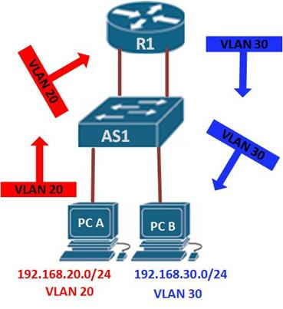
Information destined for PC B, leaves PC A with the VLAN 20 tag, when it gets to R1, the router, changes the format of this message from VLAN 20, to VLAN 30, it then sends it back to the switch and the switch finally sends the message to its intended recipient PC B.
There are two ways in which inter-VLAN routing can be accomplished.
- Traditional inter-VLAN routing
- Router-on-a-stick

Traditional inter-VLAN routing
In this type of inter-VLAN routing, a router is usually connected to the switch using multiple interfaces. One for each VLAN. The interfaces on the router are configured as the default gateways for the VLANs configured on the switch.
The ports that connect to the router from the switch are configured in access mode in their corresponding VLANs.
When a user node sends a message to a user connected to a different VLAN, the message moves from their node to the access port that connects to the router on their VLAN. When the router receives the packet, it examines the packet’s destination IP address and forwards it to the correct network using the access port for the destination VLAN. The switch now can forward the frame to the destination node since the router changed the VLAN information from the source VLAN to the destination VLAN.
In this form of inter-VLAN routing, the router has to have as many LAN interfaces as the number of VLANs configured on the switch. Therefore, if a switch has 10 VLANs, the router should have the same number of LAN interfaces.
Take the scenario shown below.
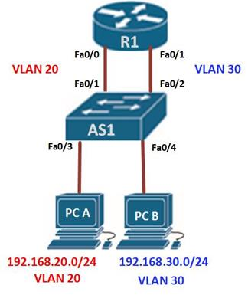
If PC A in VLAN 20, wanted to send a message to PC B in VLAN 30, the steps it would take are shown below.
- PC A would check whether the destination IPv4 address is in its VLAN if it is not, it would need to forward the traffic to its default gateway which is the ip address on Fa0/0 on R1.
- PC A then sends an ARP request to AS1 so as to determine the physical address of Fa0/0 on R1. Once the router replies, PC A can send the frame to the router as a unicast message, since AS1 has Fa0/0’s MAC address, it can forward the frame directly to R1.
- When the router receives the frame, it compares the destination IP address by referring to its routing table so as to know to which interface it should send the data towards the destination node.
- The router then sends an ARP request out the interface connected to the destination VLAN in this case out Fa0/1, when the switch receives the message, it would flood it to its ports and in this case, PC B would reply with its MAC address.
- R1 would then use this information to frame the packet and finally send it to PC B as a unicast frame.

Introduction to Router-on-a-stick
In the second type of inter-VLAN routing which is Router-on-a-stick, the router is connected to the switch using a single interface. The switchport connecting to the router is configured as a trunk link. The single interface on the router is then configured with multiple IP addresses that correspond to the VLANs on the switch. This interface accepts traffic from all the VLANs and determines the destination network based on the source and destination IP in the packets. It then forwards the data to the switch with the correct VLAN information.
As you can see in the diagram below, the router is connected to the switch AS1 using a single, physical network connection.
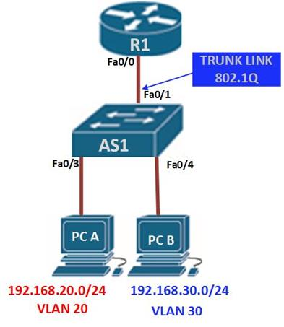
In this type of inter-VLAN routing, the interface connecting the router to the switch is usually a trunk link. The router accepts traffic that is tagged from the VLANs on the switch through the trunk link

- Router interfaces inter VLAN Routing
.

- Router sub-interfaces and inter VLAN Routing

On the router, the physical interface is divided into smaller interfaces called subinterfaces. When the router receives the tagged traffic, it forwards the traffic out to the subinterface that has the destination IP address.
subinterfaces aren’t real interfaces but they use the LAN physical interfaces on the router to forward data to various VLANs. Each subinterface is configured with an IP address and assigned a VLAN based on the design

Comparison of router-on-a-stick and traditional inter-VLAN routing
In this table, we have compared router-on-a-stick and traditional inter-VLAN routing.
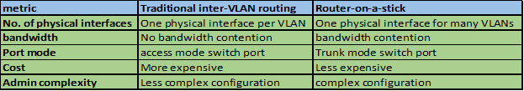
Understanding inter-VLAN routing is very important, the focus is mainly on router-on-a-stick inter-VLAN routing, however, you should not ignore the traditional inter-VLAN routing

- Router interface and sub-interface comparison

Sub- interfaces are only logical interfaces. So if you do Router interface,these show interfaces on the router you can make out physical interface E0/0 from sub interface E0/0.1 or E0/0.2. Sub-interfaces are used for creating more than one subnets, etc. A single, physical interface can be logically divided into multiple, virtual sub-interfaces.
Learning Outcome 7.2. Configure inter VLAN routing
- Configuring traditional inter-VLAN routing
In this section, we will configure Inter-VLAN routing on the router and the switch using the scenario we have just seen above. All the VLANs are active and the PCs have been assigned ports, our configuration will only be limited to the router’s inter-VLAN configuration and the switch ports connecting to R1.
The ip addressing in use is shown below.
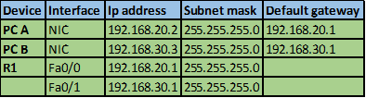
Testing connectivity using the ping command should reveal that PC A cannot ping PC B.
The first step is to configure the switchports to access the specified VLAN, fa0/1 to VLAN 20 and fa0/2 to VLAN 30. This is accomplished using the commands shown below.
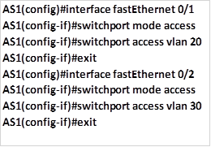
This is the only configuration on the switch, once this is done save the configuration and move on to the router.
On R1, we need to configure its interfaces with the default gateways corresponding to the VLANs. That is; on fa0/0 -192.168.20.1/24 and on fa0/1 – 192.168.30.1/24. We accomplish this using the commands shown below.
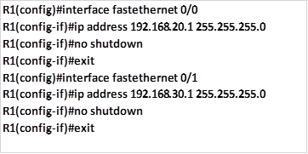
With this configuration we should save and test for connectivity on PC A and PC B, by using the ping command, and the results should be successful. Examining the routing table of R1 should show us the two routes as shown in the output below. This confirms that the router knows of the two VLANs and therefore traffic can flow between them.
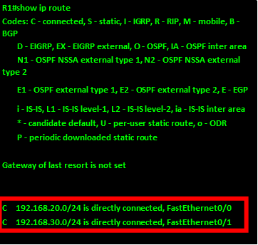
- Configure router on- a -stick -inter VLAN routing

A. SWITCH CONFIGURATION
STEP1:Creationof VLAN
Switch>EN
Switch#CONF T
Switch(config)#VLAN 10
Switch(config-vlan)#NAME ICT
Switch(config-vlan)#VLAN 20
Switch(config-vlan)# NAME ADMNISTRATION
Switch(config-vlan)#VLAN 30
Switch(config-vlan)#NAME STUDENT
Switch(config-vlan)#EXIT
STEP2: PORT ASSIGNMENT
Switch(config)#InterfaceRANGE F0/2-3
Switch(config-if-range)#SWITCHPort MODE ACCess
Switch(config-if-range)#SWItchport ACCess VLAn 10
Switch(config-if-range)#EXIT
Switch(config)#INTERface RANGe F0/4-5
Switch(config-if-range)#SWITCHPort MODE ACCess
Switch(config-if-range)#SWItchport ACCess VLAn 20
Switch(config-if-range)#EXIT
Switch(config)#INTERFace F0/6
Switch(config-if)#SWITCHPort MODE ACCess
Switch(config-if)#SWItchport ACCess VLAn 30
Switch(config-if)#EXIT
Switch(config)#INTERface F0/1
Switch(config-if)#SWITCHPort MODE TRUNk
Switch(config)#INTERface F0/5
Switch(config-if)#SWitchport VOIce VLAN 20
Switch(config-if)#SWitchport access VLAN 20
B.CONFIGURATION OF THE ROUTER
STEP1:SUB INTERFACE CONFIGURATION
For VLAN to be able to communicate ,we create the sub-interface inside the router.
outer>EN
Router#CONF T
Router(config)#INTERface G0/0
Router(config-if)#NO Shutdown
Router(config-if)#NO IP ADdress
Router(config-if)#EXIT
Router(config)#INTERface G0/0.10
Router(config-subif)#IP ADdress 192.168.10.254 255.255.255.0

Router(config-subif)#ENCapsulation Dot1Q 20
Router(config-subif)#IP ADdress 192.168.20.254 255.255.255.0
Router(config-subif)#EXIT
Router(config-subif)#INTERface G0/0.30
Router(config-subif)#ENCapsulation Dot1Q 30
Router(config-subif)#IP ADdress 192.168.30.254 255.255.255.0
Router(config-subif)#EXIT

STEP2: DHCP CONFIGURATION
Router(config)#IP DHcp POol VLAN10
Router(dhcp-config)#NETwork 192.168.10.0 255.255.255.0
Router(dhcp-config)#DEfault-router 192.168.10.254
Router(dhcp-config)#EXIT
Router(config)#IP DHcp POol VLAN20
Router(dhcp-config)#NETwork 192.168.20.0 255.255.255.0
Router(dhcp-config)#DEfault-router 192.168.20.254
Router(dhcp-config)#EXIT
Router(config)#IP DHcp POol VLAN30
Router(dhcp-config)#NETwork 192.168.30.0 255.255.255.0
Router(dhcp-config)#DEfault-router 192.168.30.254
Router(dhcp-config)#DO WR

- Verifying inter VLAN Routing
- show ip route - Provides a snapshot of the routing table entries
- show ip interface brief - Lists a brief summary of an interface's IP information and status. This command is used to verify that the VLAN interfaces and ports on the switch are up/up.

Learning Outcome7.3 ImplementLayer 3 switching operation and configuration

LU8: Perform VTP configurations

Learning Outcome 8.1 Troubleshoot Switch hardware and software operation

- Problem identification
- Solving Problems
- Troubleshooting the Power and Cooling Systems
- Environmental Reporting Features
- Troubleshooting Modules, Cables, and Connections
- Reading System LEDs
- Reading Port and Module LEDs
- System Messages
- Hardware tools:

Learning Outcome8. 2 Troubleshoot VLANs and Trunks

- Source of common problems with trunks
✓
Native VLANs mismatches
✓ Trunk mode mismatches
✓ Allowed VLANs on trunks
✓ Incorrect VLAN list
✓ VLAN and IP subnets

- Troubleshooting tools
- Show VLAN brief
- Show interface trunk
- Show interface fa0/5 switch port
- Show running - config
Learning Outcome 8.3Troubleshoot VTP configuration

• Identification of the problem:
✓ Troubleshooting VTP connectivity
- Common VTP configuration issues and solution
✓ Incompatible VTP versions
✓ VTP password configuration errors
✓ Incorrect configured VTP mode name
✓ All switches set to VTP client mode

Learning Outcom 8.4 Troubleshoot STP operation

• Identify problems
• Troubleshoot a faillure
✓ Portfast configuration error
✓ Switch or link failure
Network diameter issues

Learning Outcome 8. 5 Troubleshoot Inter-VLAN Routing configuration
- Switch configuration issues
- Router configuration issues
- IP addressing issues
- Layer 3 switch configuration issues
VLANs
SVIs

LU9.Document the work done

STEPS
- Description of network status before
- Status of network infrastructure
- describe problems found
- Review of user manual and previous report
- Suggestion of solutions on problems found
- Description of solution implementation
- Description of procedures of the task accomplished
- Network Devices, equipment and materials used
- Description of the network status after work
- Technical journal and recommendation report

